**Government Engineering College, Modasa**

**Department of Computer Engineering**

**Web Programming (3160713)**

**(2020-2021)**

**Practicals**

**Enrollment Number: -** 180160107042

**Name :** Movaliya Nishant Prakashbhai

**Div:** A **Batch:** A2

**Sem: 6th**

# Index

|  |  |  |  |
| --- | --- | --- | --- |
| **Sr. No.** | **Description** | **Pg. No.** | **Date** |
|  |  |  |  |
|  | **Introduction** |  |  |
| 1. | Study of WWW, HTTP Request and Response Protocol. List Good features of User-Friendly websites. | 5 |  |
|  | **HTML** |  |  |
| 2. | Design Information Technology Department web pages containing a description of the  Subjects/Syllabus, faculties, Facilities etc., (Use Various HTML Tags) | 10 |  |
| 3. | Design Class Time Table in HTML. | 33 |  |
| 4. | Create HTML Page as given below: List of Subjects:   1. Computer Engineering Department a. Web   Technology   * 1. Software Engineering   2. Advance Java  1. Information Technology   i. Distributed Operating System ii. Image Processing  iii. .NET Technology   1. Civil Engineering   ○ Applied Fluid Mechanics  ○ Water and Wastewater Engineering | 38 |  |
| 5. | Design Registration page in HTML. (Includes following field Name, Email, Mobile No., Date of Birth, Gender, Address, City, Hobbies, Image Upload). | 40 |  |
| 6. | Write a Program to Demonstrate Frames &  Frameset in HTML. | 44 |  |
| 7. | Demonstrate Audio and Video tags in HTML5. | 48 |  |
|  | **CSS** |  |  |
| 8. | Introduction to CSS. Demonstrate types of CSS with example. | 50 |  |
| 9. | Demonstrate the following attributes using CSS :   * Colour and background * Font * Text * Border * Margin and list | 55 |  |
| 10. | Create a Picture Book using HTML & External CSS. | 64 |  |
| 11. | Design a web page of your home town with an attractive background colour, text, images, fontsetc, Using Internal CSS only. | 66 |  |
|  | **JAVASCRIPT** |  | |
| 12. | Write a program to print the date using JavaScript. | 70 |  |
| 13. | Write a program to create a simple calculator using JavaScript. | 71 |  |
| 14. | Write a program to show the use of alert, confirm and prompt box. | 74 |  |
| 15. | Write a program to validate HTML form data using JavaScript. (Name, Age, Mobile No.) | 76 |  |
| 16. | Write a program to validate practical-13’s HTML form using regular expression in JavaScript. | 80 |  |
|  | **PHP & MySQL** |  | |
| 17. | Write a PHP script to display today’s date in ddmm-yyyy format. | 85 |  |
| 18. | Write a PHP script to check if the number is prime or not. | 86 |  |
| 19. | Write a PHP script to print the first 10 Fibonacci Numbers. | 88 |  |
| 20. | Create HTML page that contain textbox, submit / reset button. Write a PHP script to display this information and also store it into a text file. | 90 |  |
| 21. | Create Login Page with HTML, PHP &MySql. (On Successful login it should display a successful message or in case of failure it should display an unsuccessful message.) | 93 |  |
| 22. | Display Students list (Name, Enrolment No, Branch and Email Address) and demonstrate Add, Update and Delete (CRUD) functionality using HTML, PHP &MySql. | 99 |  |
|  | **AJAX - JQUERY - REST APIs** |  | |
| 23. | Using ajax retrieve data from a TEXT file and display it. | 109 |  |
| 24. | Retrieve customer information from the database and display it. | 111 |  |
| 25. | Create a Navigation Menu/Bar using JQuery. | 114 |  |
| 26. | Create an Image slider using JQuery. | 118 |  |
| 27. | Demonstrate Rest API with PHP. | 123 |  |

**Practical-1**

**Aim:** - Study of WWW, HTTP Request and response, List good features of a user-Friendly website.

* WWW:

It stands for World Wide Web also known as Web.

* + English scientist [Tim Berners-Lee](https://en.wikipedia.org/wiki/Tim_Berners-Lee) invented the World Wide Web in 1989.
  + It is a collection of resources, documents, or web pages, can be located using a URL.
  + Each page may also be interlinked by hypertext and accessible over the internet.
  + The resources of the web are transferred via HTTP(hypertext Transfer Protocol).
  + Users can access the websites or web pages using the web browser.
  + Multiple web page or web resources with the common theme and a common domain name makes up a website.
  + Websites are stored in the webserver.

* HTTP Request and Response:
  + HTTP message: HTTP messages are how data is exchanged between server and client.
  + There are two types of message:
    - HTTP Request
    - HTTP Response
  + Request sent by a client to trigger an action on the server, and server responses, the answer of request.
  + HTTP request and response use a generic message format of RFC 822 for transferring the required data.
  + This generic message format consists of the following four items: ▪ A Start-line.
    - Zero or more header fields followed by CRLF.
    - An empty line, which indicates the end of header fields.
    - (Optionally) A message body.

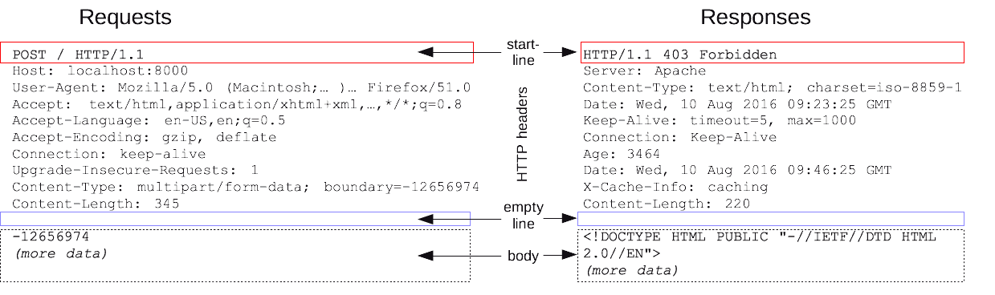

**HTTP Request Methods:**

The request method indicates the method to be performed on the resource identified by the given Request-URI. The method is case-sensitive and should always be mentioned in uppercase. The following table lists all the supported methods are as follow:

|  |  |
| --- | --- |
| **GET** | The GET method is used to retrieve information from the given server using a given URI. Requests using GET should only retrieve data and should have no other effect on the data. |
| **HEAD** | Same as GET, but it transfers the status line and the header section only. |
| **POST** | A POST request is used to send data to the server, for example, customer information, file upload, etc. using HTML forms. |
| **PUT** | Replaces all the current representations of the target resource with the uploaded content. |
| **DELETE** | Removes all the current representations of the target resource given by URI. |
| **CONNECT** | Establishes a tunnel to the server identified by a given URI. |
| **TRACE** | Performs a message loop back test along with the path to the target resource. |

**HTTP Response Header:**

The request-header fields allow the client to pass additional information about the request, and about the client itself, to the server. These fields act as request modifiers.The following table lists all the importantheader fields that can be used based on the requirement are as follow:

|  |  |
| --- | --- |
| **Accept-Charset** | The Accept-Charset request HTTP header advertises which [character encodings](https://developer.mozilla.org/en-US/docs/Glossary/character_encoding) the client understands. Using [content negotiation,](https://developer.mozilla.org/en-US/docs/Web/HTTP/Content_negotiation) the server selects one of the encodings, uses it, and informs the client of its choice within the [Content-Type](https://developer.mozilla.org/en-US/docs/Web/HTTP/Headers/Content-Type) response header, usually in a “charset=” parameter. |
| **Accept-Encoding** | The Accept-Encoding request HTTP header advertises which content encoding, usually a compression algorithm, the client is able to understand. Using [content negotiation,](https://developer.mozilla.org/en-US/docs/Web/HTTP/Content_negotiation) the server selects one of the proposals, uses it and informs the client of its choice with the [ContentEncoding](https://developer.mozilla.org/en-US/docs/Web/HTTP/Headers/Content-Encoding) response header. |
| **Accept-Language** | The Accept-Language request HTTP header advertises which languages the client is able to understand, and which locale variant is preferred. (By languages, we mean natural languages, such as English, and not programming languages.) |
| **Accept-Patch** | The Accept-Patch response HTTP header advertises which media-type the server is able to understand. |
| **Cookie** | The Cookie HTTP request header contains stored [HTTP cookies](https://developer.mozilla.org/en-US/docs/Web/HTTP/Cookies) previously sent by the server with the [Set-Cookie](https://developer.mozilla.org/en-US/docs/Web/HTTP/Headers/Set-Cookie) header. The Cookie header is optional and may be omitted if, for example, the browser's privacy settings block cookies. |
| **Host** | The **Host** request header specifies the host and port number of the server to which the request is being sent.  If no port is included, the default port for the service requested  (e.g., 443 for an HTTPS URL, and 80 for an HTTP URL) is implied. |
| **If-Match** | The If-Match HTTP request header makes the request conditional. For [GET](https://developer.mozilla.org/en-US/docs/Web/HTTP/Methods/GET) and [HEAD](https://developer.mozilla.org/en-US/docs/Web/HTTP/Methods/HEAD) methods, the server will send back the requested resource only if it matches one of the listed ETags. For [PUT](https://developer.mozilla.org/en-US/docs/Web/HTTP/Methods/PUT) and other non-safe methods, it will only upload the resource in this case. |

* Features of User-Friendly Websites:

## 1. Clear Structure, Navigation and Page Names

➢ People can arrive on any page of your site, not just your homepage. It should be easy for them to get around on their own using your navigation and page names without any guesswork. Today’s users want (and need) things to be as simple and intuitive as possible. Some points to remember and plan a clear structure.

* The [website structure](https://wiredimpact.com/guide/common-website-structures-nonprofits/) is straightforward and organized logically. • The [navigation](https://www.userfocus.co.uk/resources/navchecklist.html) isn’t overrun with too many options, opting instead for broad topics.
* Visitors don’t find themselves at dead ends, like pages without links to related content or 404 error pages.

## 2.Well-formatted and well-written content

* Use language that is simple and concise, bullet lists, headings and subheadings, other formatting techniques to make it easy for readers to skim your content. Once users get to the page of [content on your site](https://epicattorneymarketing.com/content-development-blogging/) that they are looking for, they will typically scan that page for a specific piece of information, rather than reading the entire page. So, make it easy for users to scan a page via thoughtful formatting.
* Similarly, make sure that your well-formatted content is also well-written. If your content is cluttered with typos and grammar mistakes or it just offers generic or useless information, you are most likely going to lose credibility with users (and, in turn, not get them to respond to your call-to-action or to return to your site in the future).

## 3. Simple Forms

➢ Forms are a crucial part of collecting information from website visitors, from email newsletter subscriptions to membership payments. [Applying user-friendly design to forms](https://uxdesign.cc/design-better-forms-96fadca0f49c) makes it quick and easy for people to complete and submit them, losing fewer people along the way.

* Your forms don’t ask for more information than you actually need (or require fields that aren’t crucial).
* Fields are presented in a logical, sequential way with similar questions grouped together.
* There’s an obvious way to submit the form, followed by a message letting people know their information was submitted properly.

## 4. Accessible and Adaptive

➢ In addition to accessible design, many of the factors that make a website usable for visitors with different abilities aren’t very obvious at first glance.

* Your images have descriptions in the alternative text as well as captions, while videos have subtitles or an accompanying transcript.
* You skip dense, technical language in favor of easy-to-read text with descriptive headings.
* Formatting is consistent and predictable across your pages, including the use of high contrast colors to show links and icons that represent themes or topics.

## 5. Responsive and Compatible Design

➢ Mobile optimization and compatibility is essential for any business website these days because more and more people are only relying on mobile devices to access the Internet.

This means that, if your site isn’t mobile friendly, it’s also probably not user friendly to a significant portion of your potential clients. [Responsive websites](https://wiredimpact.com/blog/nonprofit-responsive-website/) are a must.

* The navigation resizes as needed for different devices, from desktop computers to mobile.
* Text and images automatically reformat and resize to be readable and spaced correctly.
* Search engines like Google give your mobile site high marks, ensuring that your pages show up in search results.

**Practical-2**

**Aim:** Design Information Technology Department web pages containing a description of the Subjects/Syllabus, faculties, Facilities etc., (Use Various HTML Tags)

**Code:**

**index.html**

<!DOCTYPE html>

<html lang="en">

<head>

<title>GEC Modasa</title>

<link rel="stylesheet" href="gec.css">

</head>

<style>

.par ul{

padding-left: 30%;}

</style>

<body>

<div class="block">

<img src="gecmodasa.png" alt="gecmodasa logo" width="80px" height="80px" style="float: left; padding-left: 20%;">

<img src="affiliated.png" alt="gecmodasa logo" width="150pxpx" height="70px" style="float: right;padding-right:20%;">

<h1 style="text-align: center;">Government Engineering College Modasa</h1>

</div>

<br>

<div class="menu">

<ul type="none">

<li><a href="index.html">Home</a></li>

<li><a href="computerDept.html">Computer Department</a></li>

<li><a href="Syllabus.html">Syllabus</a></li>

<li><a href="faculties.html">Faculties</a></li>

<li><a href="facilites.html">Facilities</a></li>

<li><a href="contactus.html">Contact-Us</a></li>

</ul>

</div><hr style="border:0.5px solid goldenrod;">

<br>

<h2 style=" padding-left:60% ;" >About GECM</h2>

<img src="WelToGec.jpg" alt="Computer Department" style="width: 25%; float: left;padding-left: 25px;">

<section class="par">

<p>

<ul>

<li>Government Engineering College, Modasa was established in 1984 under the Directorate

of Technical Education, Gujarat State, Gandhinagar in North Gujarat region with a view

to spread out technical education in the region and hence promote industrial development.

The institute was affiliated with Hemchandracharaya North Gujarat University (HNGU),

Patan from 1984 to 2007. The institute is affiliated to Gujarat Technological University,

Ahmedabad from 2008. It is recognized by All India Council for Technical Education (AICTE),

New Delhi.

</li><br>

<li>The institute was started with two under graduate courses, with an intake of 60 each.

At present it runs seven under graduate courses and two post graduate courses.

Each department has well established laboratories, computer centers and well qualified

staff.

</li><br>

<li>

The institue is situated at a distance of about 100 km. towards North of Ahmedabad on Modasa-Shamalaji

State Highway on the outskirts of Modasa town, the district Headquater of Aravalli district. The college

is connnected by state and national Highway with Ahmedabad, Himmatnagar, Baroda, and Udaipur. The campus

is spread over more than 112 Acres of land having natural asthetics and topographical surroundings.

</li><br>

</ul>

</p>

</section>

<br><br><br> <br>

<h2 style="text-align: center;">Vision & Mission</h2>

<div class="visionandmission">

<div class="vision">

<img src="" alt="">

<h3>Vision</h3>

<p>

To be a leading institution ensuring Academic Excellence, Research, Nurturing Innovation and Entrepreneurial Attitude to produce competent technocrats for service to Nation.

</p>

</div>

<div class="Missio">

<img src="" alt="">

<h3>Mission</h3>

<p>

<ol>

<li>To be a student centric institute imbibing experiential, innovative and lifelong learning skills, addressing societal problems.</li>

<li>To create a conducive ecosystem for Research, innovation & extension services.</li>

<li>To inculcate entrepreneurial attitude and values amongst Learners.</li>

<li>To Collaborate with Industries and other institutions to strengthen symbiotic relations</li>

<li>To mentor aspiring Institutions to unleash their potential, towards nation building.</li>

</ol>

</p>

</div>

<div class="Core Values">

<img src="" alt="">

<h3>Core Values</h3>

<p>Our core values are quality, equality, morality, environmental sustainability, energy saving and strong commitment to the cause of technical education and services. We believe and put efforts towards:</p>

<ul>

<li>Equitable and harmonious growth of students, staff, society, industry.</li>

<li>Quality services and education to train students enlightened with vision to be commited citizen with strong civic sense and high moral standards having concern for local and global values.</li>

</ul>

</div><br><br>

<p style="text-align: center;">© All Rights Reserved 2021.</p>

<p style="text-align: center;"><i>Design By : Nishant</i></p>

</body>

</html>

**gec.css**

body{

background: linear-gradient(90deg,#FF512F,#DD2476);

color: white;

font-family: 'Montserrat', sans-serif;

}

.block{

margin: 0;

padding: 0;

overflow: hidden;

background-color: transparent;

}

.menu ul {

list-style-type: none;

margin: 0;

padding: 0;

overflow: hidden;

background-color: transparent;

}

.menu li{

float: left;

padding: 20px;

}

.menu li:hover{

background: linear-gradient(57deg,#f14492,#f8765c);

background-color: white;

text-decoration: none;

}

.menu a{

text-decoration: none;

color: white;

}

.tball table{

border: 1px solid white;

padding: 15px;

background: linear-gradient(57deg,#C33764 , #1D2671);

}

.tball td{

padding-inline-end: 10px;

}

.fname{

font-size: 20px;

font-weight: bold;

}

.li1{

float: left;padding-left: 15%; padding-top: 1%;

}

.li2{float: right;padding-right: 20%; padding-top:0%;}

**Output:**



**computerDept.html**

<html>

<head>

<title>Computer Department</title>

<link rel="stylesheet" href="gec.css">

</head>

<body>

<div class="block">

<img src="gecmodasa.png" alt="gecmodasa logo" width="80px" height="80px" style="float: left; padding-left: 20%;">

<img src="affiliated.png" alt="gecmodasa logo" width="150pxpx" height="70px" style="float: right;padding-right:20%;">

<h1 style="text-align: center;">Government Engineering College Modasa</h1>

</div>

<br>

<div class="menu">

<ul type="none">

<li><a href="index.html">Home</a></li>

<li><a href="computerDept.html">Computer Department</a></li>

<li><a href="Syllabus.html">Syllabus</a></li>

<li><a href="faculties.html">Faculties</a></li>

<li><a href="facilities.html">Facilities</a></li>

<li><a href="contactus.html">Contact-Us</a></li>

</ul>

</div><hr style="border:0.5px solid goldenrod;">

<br>

<u><h2 style="text-align: center;">About Department</h2></u>

<p>This department is running from 2001. The staff has developed required laboratories in the areas like Computer Hardware, Computer Networking & Security, Database Management System, Computer Graphics and Internet Technology in tune with real-time systems.

</p>

<p>The Internet access is provided to the students to update their knowledge in various fields. Currently, a project under AICTE Grant for Campus Networking is under process. The Computer Department is equipped with around 150 computers with multimedia software and LAN Systems with Internet connection.

</p>

<p>The Department has purchased Latest Computer Servers and Network-based online teaching system software named Content Server. The department is sharing all infrastructural facilities of Information Technology Department. The laboratories in the department are well developed to cater needs of the students.

Department is also offering Post Graduate course in Computer Science & Engineering since 2010.</p>

<br>

<u><h2 style="text-align: center;">About Course</h2></u>

<p>Computer engineering blends together computer science and electrical engineering to further advancements in digital

technology, computer networking, and computer systems. In turn, computer engineers use their extensive knowledge of

hardware and software design and computer programming to make computing platforms and applications more efficient and

effective. Seamlessly integrating the latest innovations, computer engineers develop new computer hardware, design and

implement software applications, and enhance the capabilities of networks and communications systems.

</p>

<p>Computer engineers work with hardware and software, ensuring that the two are seamlessly integrated and functioning properly.

Computer engineers focus on innovation—making computing systems safer, faster and more powerfull. At the career level, there

are two main avenues: hardware and software engineering. Hardware engineers focus their skills on computer systems and

components, designing microprocessors, circuit boards, routers and other embedded devices. On the software side,

these engineers create, test and debug programs and applications that run on computers, mobile devices and more.

</p>

</body>

</html>

**Output:**

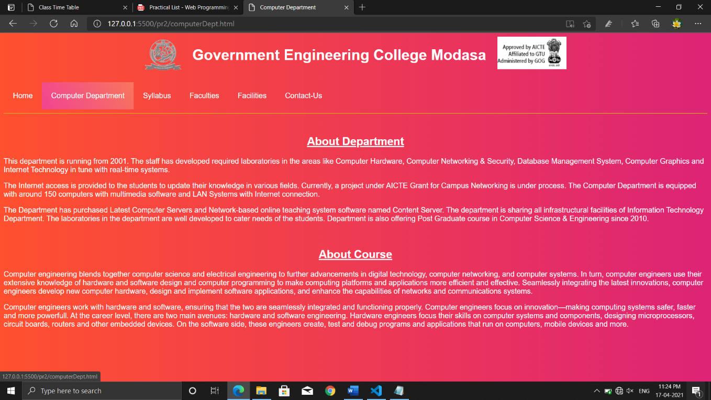

**Syllabus.html**

<html>

<head>

<title>Syllabus</title>

<link rel="stylesheet" href="gec.css">

</head>

<body>

<div class="block">

<img src="gecmodasa.png" alt="gecmodasa logo" width="80px" height="80px" style="float: left; padding-left: 20%;">

<img src="affiliated.png" alt="gecmodasa logo" width="150pxpx" height="70px" style="float: right;padding-right:20%;">

<h1 style="text-align: center;">Government Engineering College Modasa</h1>

</div>

<br>

<div class="menu">

<ul type="none">

<li><a href="index.html">Home</a></li>

<li><a href="computerDept.html">Computer Department</a></li>

<li><a href="Syllabus.html">Syllabus</a></li>

<li><a href="faculties.html">Faculties</a></li>

<li><a href="facilities.html">Facilities</a></li>

<li><a href="contactus.html">Contact-Us</a></li>

</ul>

</div><hr style="border:0.5px solid goldenrod;">

<br>

<h1 style="text-align: center;">Syllabus</h1><br><br>

<center>

<iframe src="http://syllabus.gtu.ac.in/Syllabus.aspx?tp=BE" frameborder="0" style="width: 80%;height: 100%;"></iframe>

</center>

</body>

</html>

**Output:**

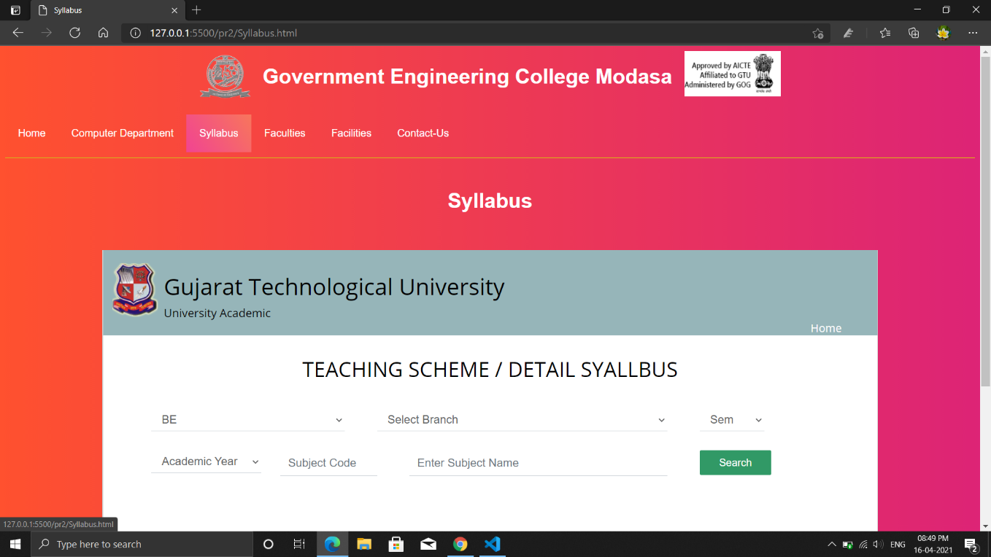

**faculties.html**

<!DOCTYPE html>

<html lang="en">

<head>

<title>Faculties</title>

<link rel="stylesheet" href="gec.css">

</head>

<body class="b">

<div class="block">

<img src="gecmodasa.png" alt="gecmodasa logo" width="80px" height="80px" style="float: left; padding-left: 20%;">

<img src="affiliated.png" alt="gecmodasa logo" width="150pxpx" height="70px" style="float: right;padding-right:20%;">

<h1 style="text-align: center;">Government Engineering College Modasa</h1>

</div>

<br>

<div class="menu">

<ul type="none">

<li><a href="index.html">Home</a></li>

<li><a href="computerDept.html">Computer Department</a></li>

<li><a href="Syllabus.html">Syllabus</a></li>

<li><a href="faculties.html">Faculties</a></li>

<li><a href="facilities.html">Facilities</a></li>

<li><a href="contactus.html">Contact-Us</a></li>

</ul>

</div><hr style="border:0.5px solid goldenrod;">

<br>

<h2 style="text-align: center;">Faculties</h2><br><br>

<div class="tball">

<table>

<tr>

<td rowspan="7">

<img src="ce_mbc.jpeg"

alt="M.B. Chaudhari" height="200px" width="170px">

</td>

<td colspan="3" class="fname">M B Chaudhari</td>

</tr>

<tr>

<td>Designation</td>

<td>:</td>

<td>Professor</td>

</tr>

<tr>

<td>Qualification</td>

<td>:</td>

<td>M.E. Computer Engineering</td>

</tr>

<tr>

<td>Experience</td>

<td>:</td>

<td>28 years</td>

</tr>

<tr>

<td>Date of joining</td>

<td>:</td>

<td>01-01-2019</td>

</tr>

<tr>

<td>Area of Interest</td>

<td>:</td>

<td>Advanced Computing</td>

</tr>

<tr>

<td>Email</td>

<td>:</td>

<td>hod_computer@gecmodasa.org</td>

</tr>

</table>

<br>

<table>

<tr>

<td rowspan="7">

<img src="MMG.jpg"

alt="M.M. Goyani" height="200px" width="170px">

</td>

<td colspan="3" class="fname">Dr. Mahesh M. Goyani</td>

</tr>

<tr>

<td>Designation</td>

<td>:</td>

<td>Assistant Professor</td>

</tr>

<tr>

<td>Qualification</td>

<td>:</td>

<td>Ph.D, B.A., M.E., B.E.</td>

</tr>

<tr>

<td>Experience</td>

<td>:</td>

<td>15 Years</td>

</tr>

<tr>

<td>Date of joining</td>

<td>:</td>

<td>18-01-2016</td>

</tr>

<tr>

<td>Area of Interest</td>

<td>:</td>

<td>Pattern Recognition, Computer Vision, Machine Learning,

Image Processing, Data Mining, Analysis of Algorithm,

Computer Graphics</td>

</tr>

<tr>

<td>Email</td>

<td>:</td>

<td>mgoyani@gmail.com</td>

</tr>

</table><br>

<table>

<tr>

<td rowspan="7">

<img src="AKD.jpg"

alt="A.K. DODIYA" height="200px" width="170px">

</td>

<td colspan="3" class="fname">DODIYA ANIRUDDHSINH KARSHANBHAI</td>

</tr>

<tr>

<td>Designation</td>

<td>:</td>

<td>ASSISTANT PROFESSOR</td>

</tr>

<tr>

<td>Qualification</td>

<td>:</td>

<td>M.E.(CST)</td>

</tr>

<tr>

<td>Experience</td>

<td>:</td>

<td>8 years</td>

</tr>

<tr>

<td>Date of joining</td>

<td>:</td>

<td>27-09-2016</td>

</tr>

<tr>

<td>Area of Interest</td>

<td>:</td>

<td>Cloud Computing, Operating System</td>

</tr>

<tr>

<td>Email</td>

<td>:</td>

<td>akdodiya@gecmodasa.org</td>

</tr>

</table>

</div>

</body>

</html>

**Output:**

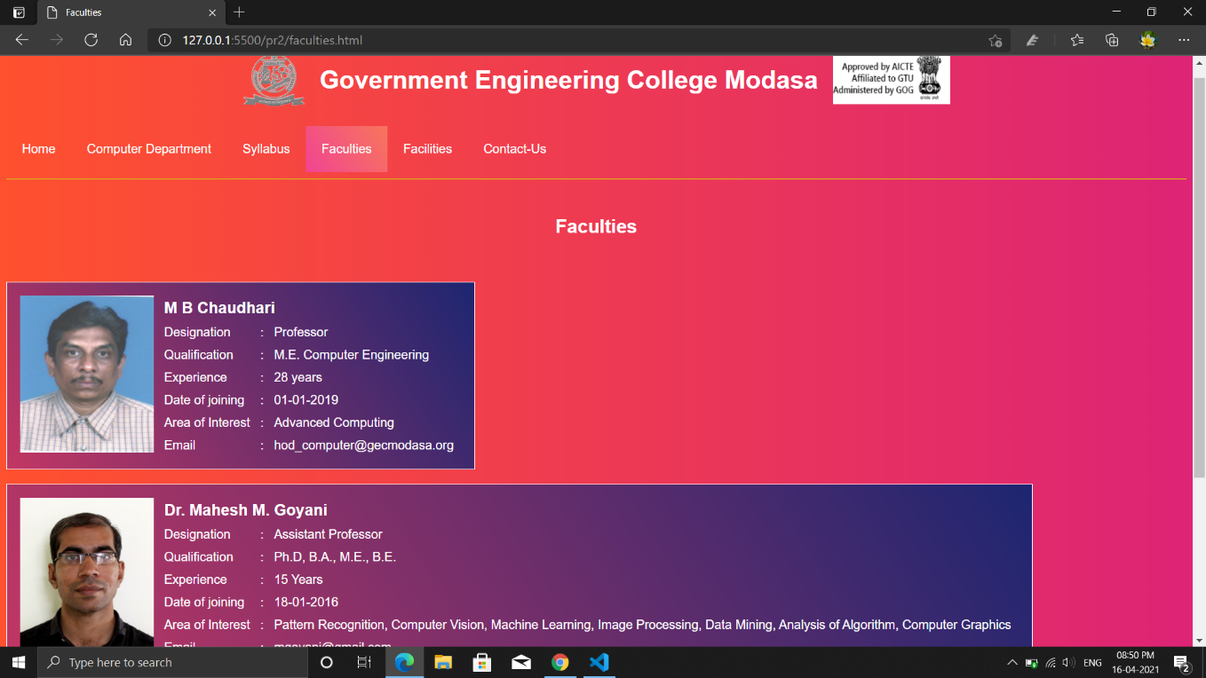

**facilities.html**

<!DOCTYPE html>

<html lang="en">

<head>

<title>Facilities</title>

<link rel="stylesheet" href="gec.css">

</head>

<body>

<div class="block">

<img src="gecmodasa.png" alt="gecmodasa logo" width="80px" height="80px" style="float: left; padding-left: 20%;">

<img src="affiliated.png" alt="gecmodasa logo" width="150pxpx" height="70px" style="float: right;padding-right:20%;">

<h1 style="text-align: center;">Government Engineering College Modasa</h1>

</div>

<br>

<div class="menu">

<ul type="none">

<li><a href="index.html">Home</a></li>

<li><a href="computerDept.html">Computer Department</a></li>

<li><a href="Syllabus.html">Syllabus</a></li>

<li><a href="faculties.html">Faculties</a></li>

<li><a href="facilities.html">Facilities</a></li>

<li><a href="contactus.html">Contact-Us</a></li>

</ul>

</div><hr style="border:0.5px solid goldenrod;">

<br>

<h2 style="text-align: center;">Facilities</h2><br>

<div class="li1">

<h3>Campus Facilities</h3>

<ul>

<li><strong>Student Section</strong></li>

<li><strong>Library</strong></li>

<li><strong>Hostel & Mess Facility</strong></li>

<li><strong>Sports & Gymkhana</strong></li>

<li><strong>Seminar Room</strong></li>

<li><strong>Computer & Internet Facility</strong></li>

<li><strong>CCTV Survilliance System</strong></li>

<li><strong>Video Conferencing System</strong></li>

</ul>

</div>

<div class="li2">

<h3>Department Facilities</h3>

<ul type ="circle">

<li>Wi-Fi enabled Department</li>

<li>System Lab</li>

<li>Programming Language Lab</li>

<li>Digital Logic Lab</li>

<li>Seminar Halls</li>

<li>Campus Wide Fiber Optic Cable Network</li>

<li>Network Lab</li>

<li>DBMS Lab</li>

<li>Operating System Lab</li>

<li>Digital Learning Lab</li>

</ul>

</div>

</body>

</html>

**Output:**

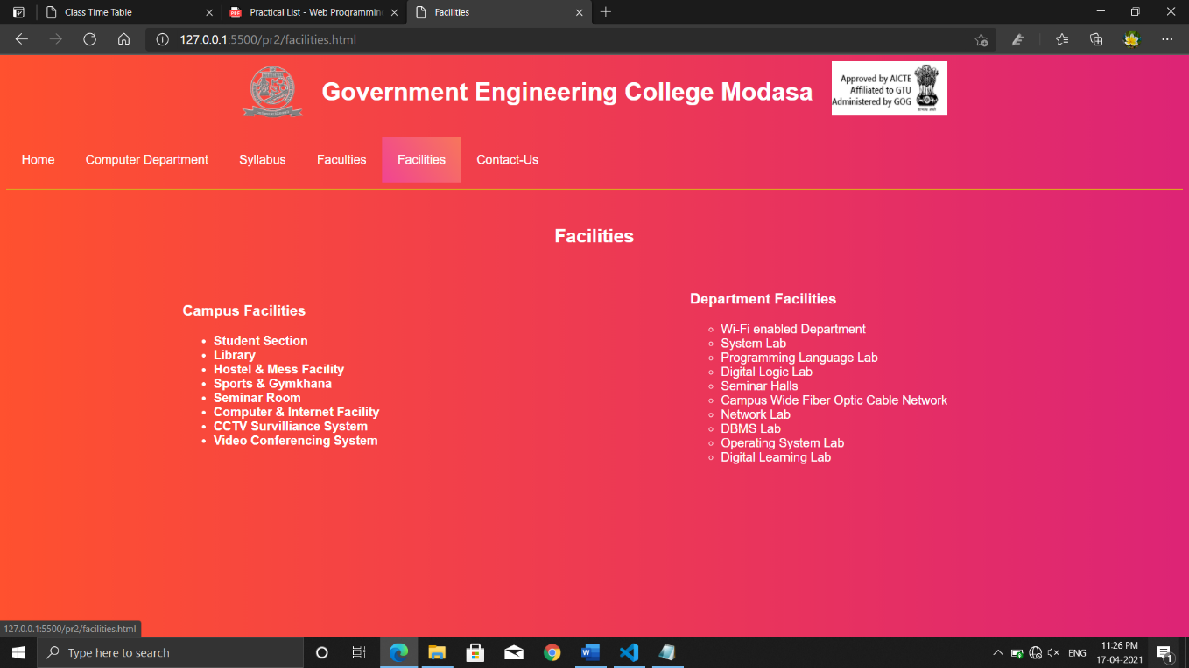

**contactus.html**

<!DOCTYPE html>

<html lang="en">

<head>

<title>Contact Us</title>

<link rel="stylesheet" href="gec.css">

</head>

<body>

<div class="block">

<img src="gecmodasa.png" alt="gecmodasa logo" width="80px" height="80px" style="float: left; padding-left: 20%;">

<img src="affiliated.png" alt="gecmodasa logo" width="150pxpx" height="70px" style="float: right;padding-right:20%;">

<h1 style="text-align: center;">Government Engineering College Modasa</h1>

</div>

<br>

<div class="menu">

<ul type="none">

<li><a href="index.html">Home</a></li>

<li><a href="computerDept.html">Computer Department</a></li>

<li><a href="Syllabus.html">Syllabus</a></li>

<li><a href="faculties.html">Faculties</a></li>

<li><a href="facilities.html">Facilities</a></li>

<li><a href="contactus.html">Contact-Us</a></li>

</ul>

</div><hr style="border:0.5px solid goldenrod;">

<br>

<h2 style="text-align: center;">Contact Us</h2>

<h3>College Campus</h3>

<ul>

<li>Shamlaji Road, Modasa, District Aravalli , Gujarat, India 383315</li>

<li><a href="mailto:gec-modasa-dte@gujarat.gov.in">gec-modasa-dte@gujarat.gov.in</a></li>

<li>(+91)02774 242 633/634</li>

<li><a href="http://www.gecmodasa.ac.in">http://www.gecmodasa.ac.in</a></li>

</ul>

<h3>Working Hours</h3>

<ul>

<li><b>Monday-Friday:</b> 10:30am to 6:10pm</li>

<li><b>Saturday:</b> 10:30am to 6:10pm (Closed on 2nd & 4th)</li>

<li><b>Sunday:</b> Closed</li>

</ul>

<h3>Why we are?</h3>

<p>The mission of Government Engineering College, Modasa is to deliver technical programs and

service to meet the changing need of society and industry and thereby contribute to the overall

techno-economical development

of the State in particular and national in general and improve quality of life of communities.</p>

</body>

</html>

**Output:**

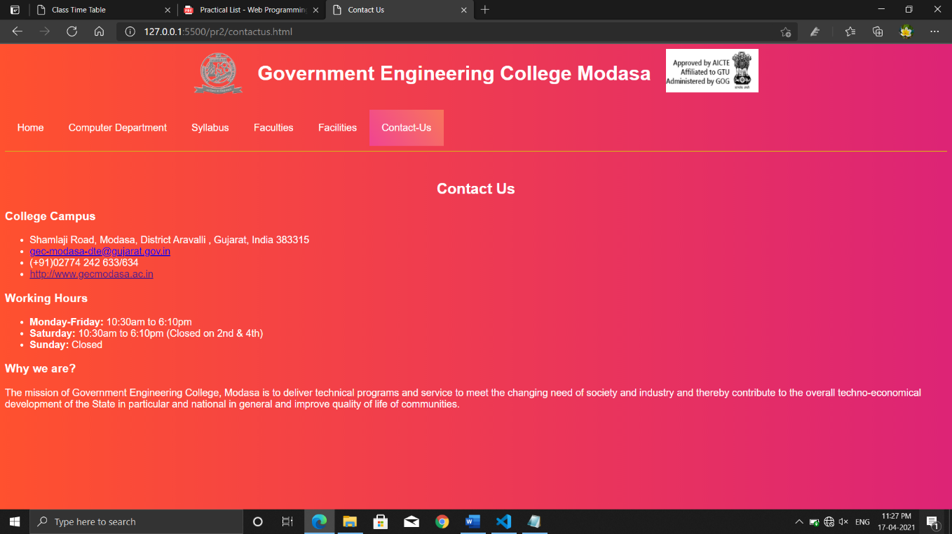

**Practical -3**

**Aim:** - Design Class Time Table in HTML.

**Code:**

<html>

<head>

<title>Class Time Table</title>

<style>

body{background: linear-gradient(90deg,#11998E,#38EF7D);}

table,

th,

td {

border: 1.1px solid gray;

border-collapse: collapse;

color: white;

padding: 8px;

font-family: 'Montserrat', sans-serif;

}

th,

td {

text-align: center;

}

table{background: linear-gradient(57deg,#C33764 , #1D2671);}

</style>

</head>

<body>

<u style="color:#FC9426;"><h1 style="text-align: center; color: gold;">Time Table</h1></u>

<table style="width:100%">

<tr>

<th colspan="8">GOVERNMENT ENGINEERING COLLEGE MODASA</th>

</tr>

<tr>

<th colspan="8">CE/IT DEPARTMENT</th>

</tr>

<tr>

<th colspan="8">CLASS TIME TABLE</th>

</tr>

<tr>

<th colspan="4">CLASS</th>

<th colspan="2">6CEA</th>

<th colspan="2">w.e.f.10/12/2020</th>

</tr>

<tr>

<th></th>

<th>TIME</th>

<th>MON</th>

<th>TUE</th>

<tH>WED</tH>

<th>THU</th>

<th>FRI</th>

<th>SAT</th>

</tr>

<tr>

<td>1</td>

<td>10:55 TO 11:55</td>

<td>MPI(3160712)-PRG-8109</td>

<td>MPI(3160712)-VRP-8109</td>

<td>IPDC(3160003)-RNV-8109</td>

<td>TOC(3160704)-NSC-8109</td>

<td>IOT(3160716)-VRP-8109</td>

<td rowspan="2">A1 TOC(3160704)-MMG-8213</td>

</tr>

<tr>

<td>2</td>

<td>11:55 TO 12:55</td>

<td>WP(3160713)-ADC-8109</td>

<td>WP(3160713)-JBB-8109</td>

<td>IPDC(3160003)-ABP-8109</td>

<td>AJP(3160707)-VAR-8109</td>

<td>AJP(3160707)-VAR-8109</td>

</tr>

<tr>

<td>3</td>

<td>13:20 TO 14:20</td>

<td>TOC(3160704)-MMG-8109</td>

<td>TOC(3160704)-MMG-8109</td>

<td>AJP(3160707)-MCZ-8109</td>

<td>MPI(3160712)-PRG-8109</td>

<td>TOC(3160704)-NSC-8109</td>

<td rowspan="2">A2 TOC(3160704)-MMG-8213</td>

</tr>

<tr>

<td>4</td>

<td>14:20 TO 15:20</td>

<td></td>

<td></td>

<td>WP(3160713)-JBB-8109</td>

<td>MPI(3160712)-PRG-8109</td>

<td></td>

</tr>

<tr>

<td>5</td>

<td>15:30 TO 16:30</td>

<td rowspan="2">A1 MPI-PRG-8117 <br>A2 IOT-MHV-8112 <br>A3 AJP-VAR-8113</td>

<td rowspan="2">A1 IOT-VRP-8117 <br>A2 DE-MVC-8113 <br>A3 WP-ADC-8115</td>

<td rowspan="2">A1 WP-ADC-8113 <br>A2 MPI-PRG-8115 <br>A3 DE-RNV-8116</td>

<td rowspan="2">A1 AJP-PAB-8113 <br>A2 WP-NA-8115<br>A3 MPI-PRG-8116</td>

<td rowspan="2">A1 DE-MVC-8113 <br>A2 AJP-PAB-8113<br>A3 IOT-VRP-8116</td>

<td rowspan="2">A3 TOC(3160704)-MMG-8213</td>

</tr>

<tr>

<td>6</td>

<td>16:30 TO 17:30</td>

</tr>

</table>

</body>

</html>

**Output:**

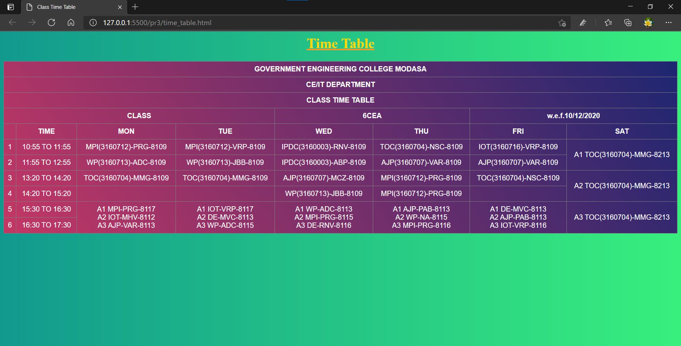

**Practical-4**

**Aim:** - Create HTML Page as given below:

List of Subjects:

1. Computer Engineering Department

a. Web Technology

b. Software Engineering

c. Advance Java

2. Information Technology

i. Distributed Operating System

ii. Image Processing

iii. .NET Technology

3. Civil Engineering

○ Applied Fluid Mechanics

○ Water and Wastewater Engineering

**Code:**

<!DOCTYPE html>

<html lang="en">

<head>

<meta charset="UTF-8">

<meta http-equiv="X-UA-Compatible" content="IE=edge">

<meta name="viewport" content="width=device-width, initial-scale=1.0">

<title>List</title>

</head>

<body>

<div style="background-color: goldenrod; color: white;">

<h2>List of Subjects:</h2><hr>

<ol type="1">

<li>Computer Engineering Department</li>

<ol type="a">

<li>Web Technology</li>

<li>Software Engineering</li>

<li>Advance Java</li>

</ol>

<li>Information Technology</li>

<ol type="i">

<li>Distributed Operating System</li>

<li>Image Processing</li>

<li>.NET Technology</li>

</ol>

<li>Civil Engineering</li>

<ul style="list-style-type: circle;">

<li>Applied Fluid Mechanics</li>

<li>Water and Wastewater Engineering</li>

</ul>

</ol>

</body>

</html>

**Output:-**

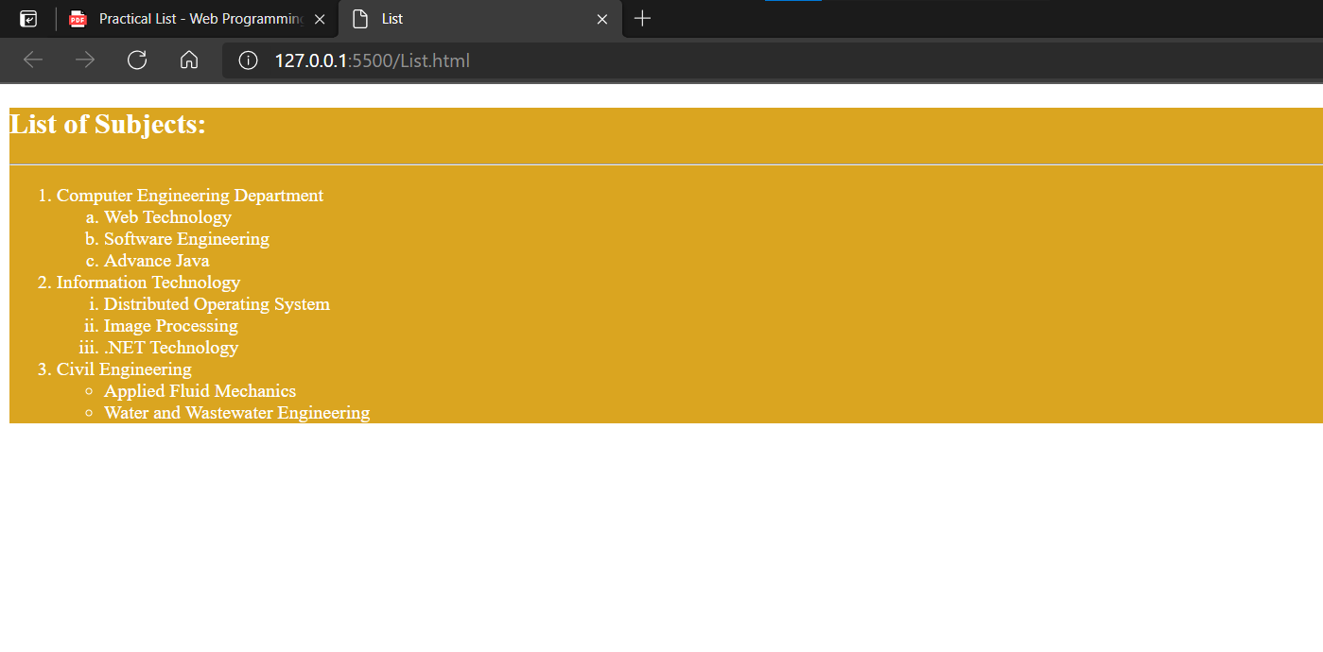

**Practical-5**

**Aim:** Design Registration page in HTML. (Includes following field Name, Email, Mobile No., Date of Birth, Gender, Address, City, Hobbies, Image Upload).

**Code:**

<html>

<head>

<title>Registartion Form</title>

<style>

div{

margin-bottom: 15px;

}

body{

background:linear-gradient(45deg, #405de6, #5851db, #833ab4, #c13584, #e1306c, #fd1d1d);

color: white;

font-family: 'Montserrat', sans-serif;

}

.button{background: linear-gradient(45deg, #df0e3c, #3c56e7);color: white;

border-radius: 4px; padding: 10px 25px; border-color: white;}

form input,textarea{ border-radius: 4px; border-color: white; }

form{text-align: center;}

table td{padding: 10px;}

</style>

</head>

<body>

<h1 align="center" style="color:white;background:black">Registration Form</h1>

<form action="" method="POST">

<fieldset>

<table align="center">

<legend style="text-align: left;">Registartion Form:</legend>

<tr>

<div>

<td><label for="username">Name : </label></td>

<td><input type="text" name="username" ></td>

</div>

</tr>

<tr>

<div>

<td> <label for="email">Email Id :</label></td>

<td><input type="email" name="email"></td>

</div>

</tr>

<tr>

<div>

<td><label for="mobile">Mobile No. :</label></td>

<td><input type="tel" name="mobile"></td>

</div></tr>

<div>

<td><label for="dateofbirth">Select Birth Date :</label></td>

<td><input type="date" name="dateofbirth"></td>

</div></tr>

<tr>

<div>

<td><label for="gender">Gender :</label></td>

<td><input type="radio" name="gender" value="male"> Male

<input type="radio" name="gender" value="female">Female

<input type="radio" name="gender" value="other">Other </td>

</div></tr>

<div>

<td><label for="address">Address :</label>

<td> <textarea cols="20" rows="4" style="vertical-align: top;"></textarea></td><br><br>

<tr>

<td> <label for="city">City :</label></td>

<td><input type="city" name="city"></td></tr>

</div>

<tr><div>

<td> <label for="hobby">Hobby :</label></div></td>

<td><input type="checkbox" name="reading">Reading

<input type="checkbox" name="cricket">Cricket

<input type="checkbox" name="yoga">Yoga

<input type="checkbox" name="programming">Programming

<input type="checkbox" name="travelling">Travelling

</td>

</div></tr>

<tr><div>

<td><label for="imgupload">Upload a Image : </label></td>

<td><input type="file" name="imgupload"></td>

</div></tr><br>

<tr><div >

<td><input type="submit" name="submit" value="Submit" class="button"></td>

<td><input type="reset" name="reset" value="Reset" class="button"></td>

</div></tr>

</table>

</fieldset>

</form>

</body>

</html>

**Output:**

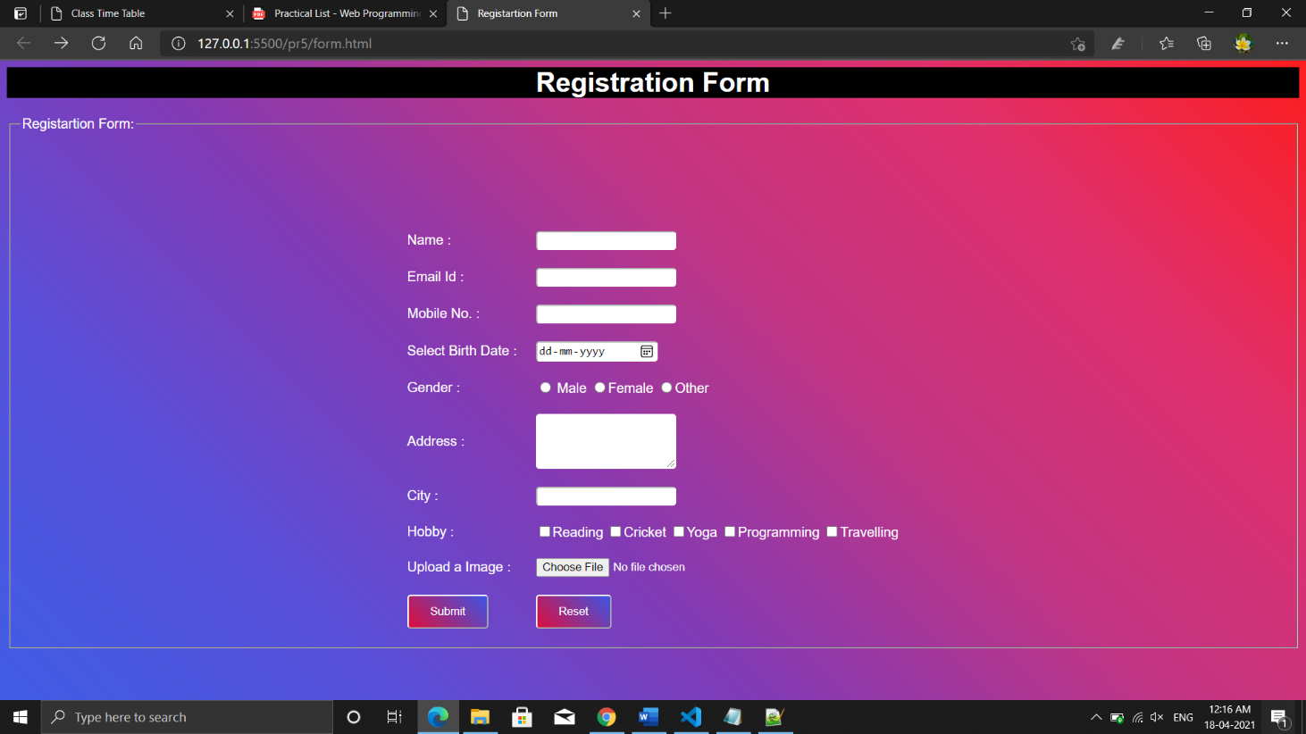

**Practical-6**

**Aim:** Write a Program to Demonstrate Frames & Frameset in HTML

**Code:**

**Index.html**

<html>

<head>

<title>GEC Modasa</title>

</head>

<frameset cols=20%,80%>

<frame src="Target_page.html" name="" />

<frame src="AboutGecM.html" name="frames"/>

<noframes>

<body>Your browser does not support frames.</body>

</noframes>

</frameset>

</html>

**AboutGecM.html**

<html>

<head>

<title>About Gec Modasa</title>

</head>

<link rel="preconnect" href="https://fonts.gstatic.com">

<link href="https://fonts.googleapis.com/css2?family=Montserrat:wght@100&display=swap">

<style>

*{

background: linear-gradient(90deg,#D4145A,#FBB03B);

font-family: 'Montserrat', sans-serif;

color: white;

}

</style>

<body>

<h1>About GECM</h1><hr>

<ul>

<li>Government Engineering College, Modasa was established in 1984 under the Directorate of Technical Education, Gujarat State, Gandhinagar in North Gujarat region with a view to spread out technical education in the region and hence promote industrial development.

The institute was affiliated with Hemchandracharaya North Gujarat University (HNGU), Patan from 1984 to 2007. The institute is affiliated to Gujarat Technological University, Ahmedabad from 2008.

It is recognized by All India Council for Technical Education (AICTE), New Delhi.

</li>

<li>The institute was started with two under graduate courses, with an intake of 60 each. At present it runs seven under graduate courses and two post graduate courses. Each department has well established laboratories, computer centers and well qualified staff.</li>

<li>The institue is situated at a distance of about 100 km. towards North of Ahmedabad on Modasa-Shamalaji State Highway on the outskirts of Modasa town, the district Headquater of Aravalli district. The college is connnected by state and national Highway with Ahmedabad, Himmatnagar, Baroda, and Udaipur.

The campus is spread over more than 112 Acres of land having natural asthetics and topographical surroundings.</li>

</ul>

</body>

</html>

**Output:**

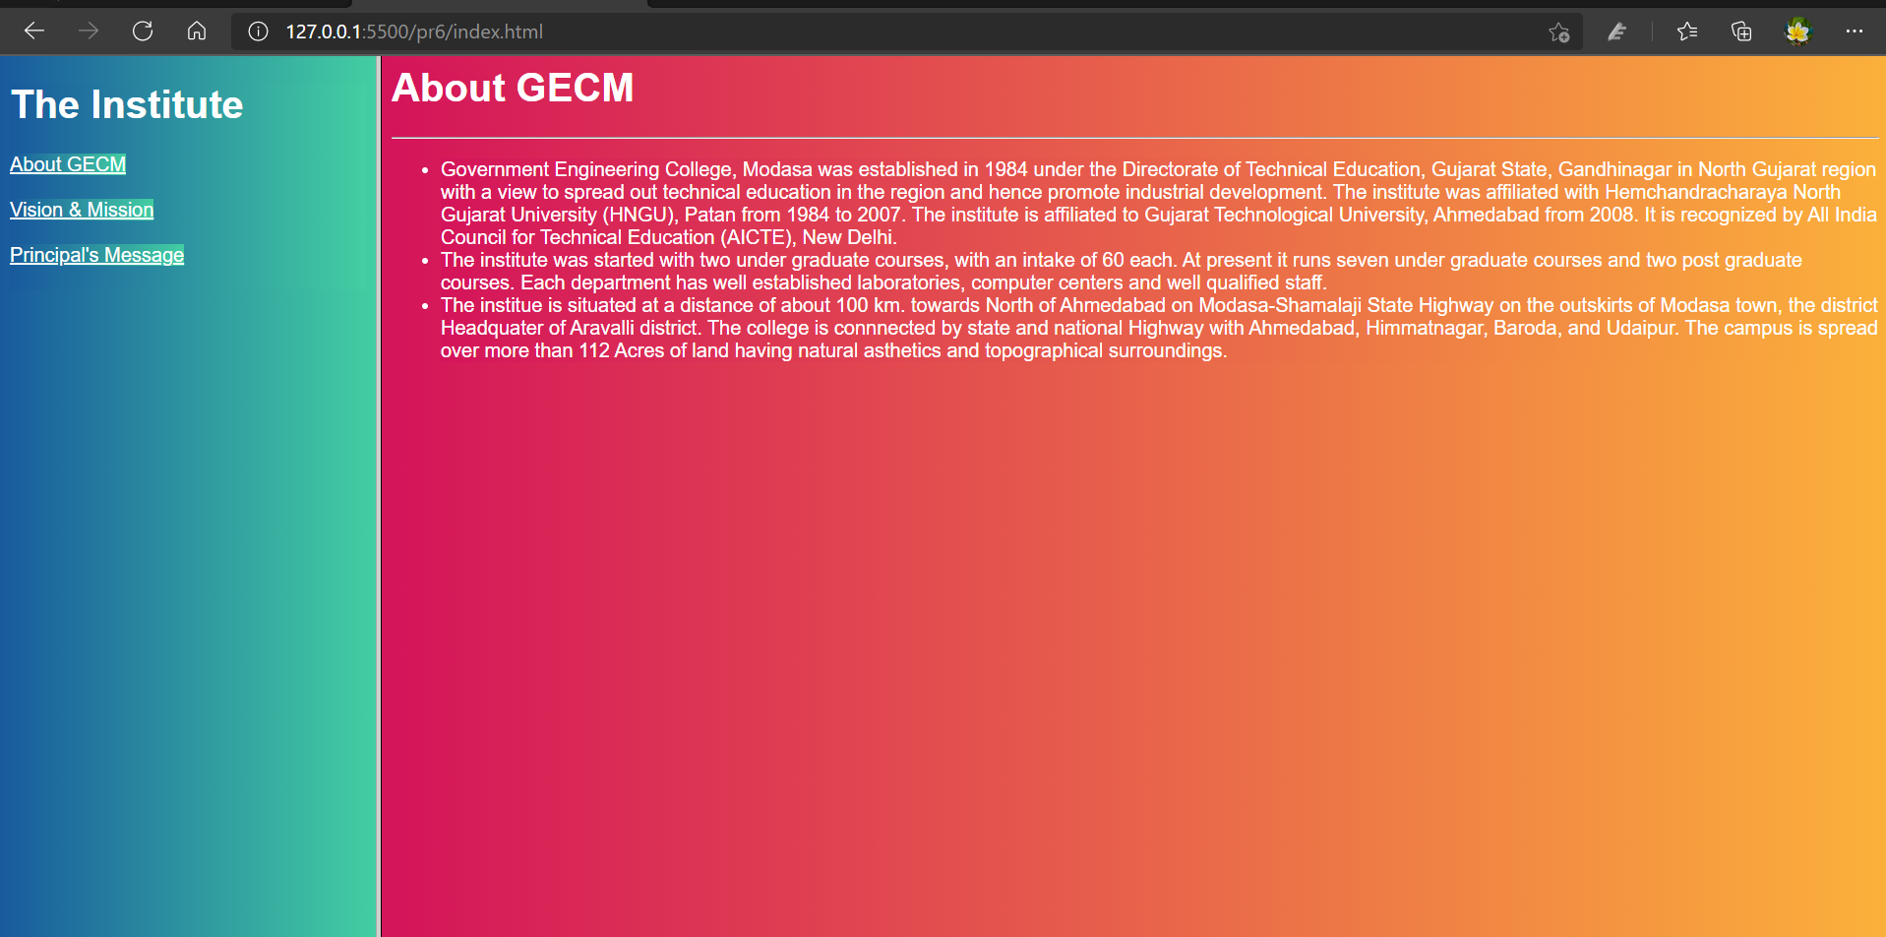

**Output:**

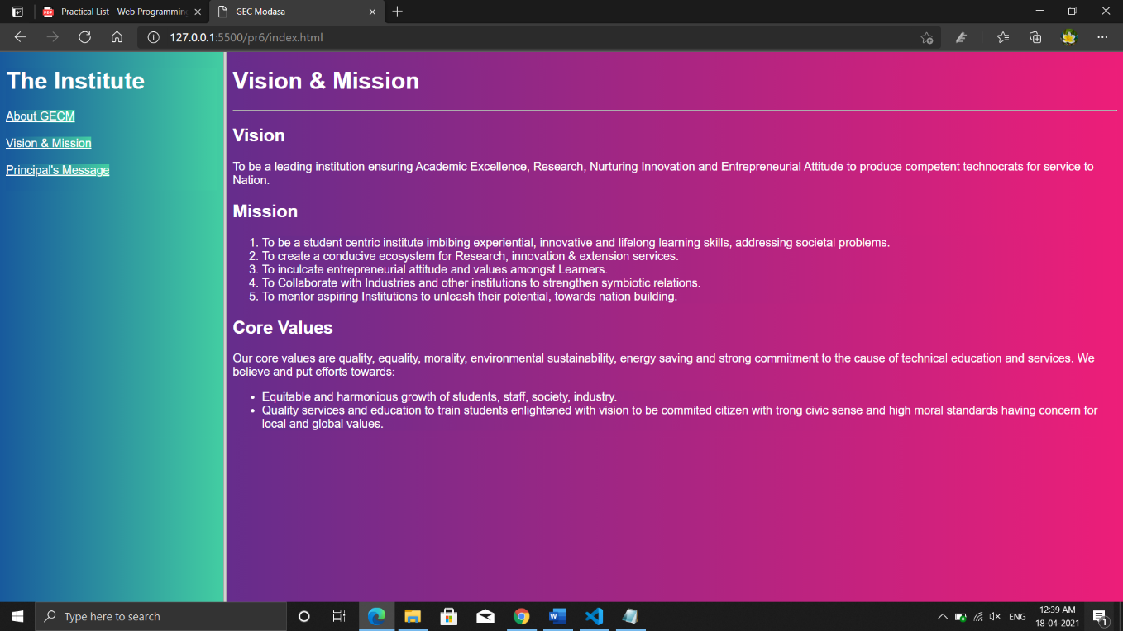

**Output:**

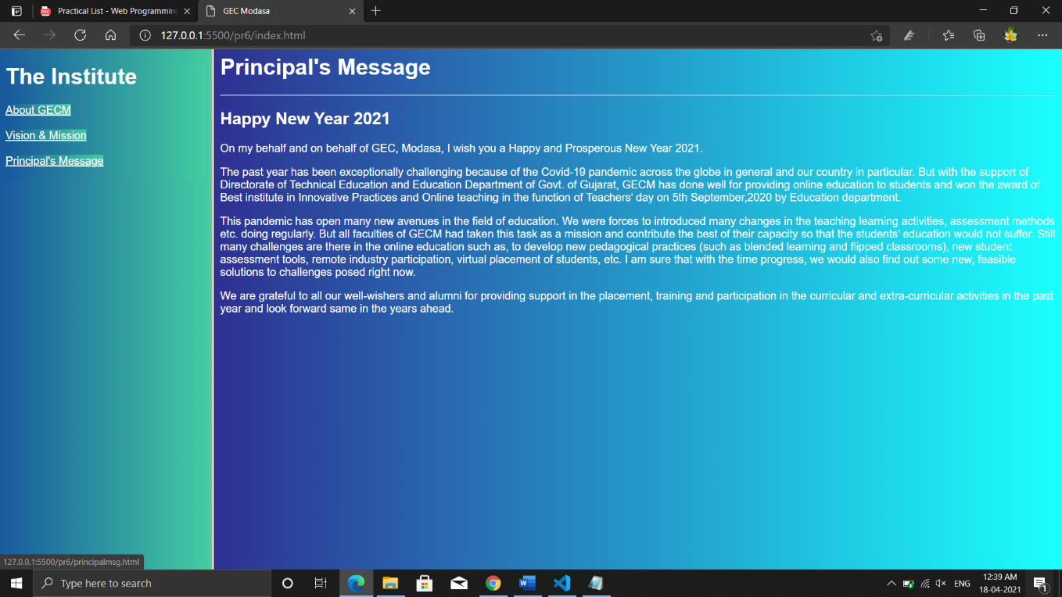

**Practical-7**

**Aim:** Demonstrate Audio and Video tags in HTML5.

**Code:**

<!DOCTYPE html>

<html>

<head>

<title>Practical 7</title>

</head>

<link rel="preconnect" href="https://fonts.gstatic.com">

<link href="https://fonts.googleapis.com/css2?family=Montserrat:wght@100&display=swap">

<style>

*{

background: linear-gradient(90deg,#11998E,#38EF7D);

font-family: 'Montserrat', sans-serif;

color: white;

text-align: center;

}

</style>

<body>

<h1>Video Player</h1>

<video src="Happy Diwali.mp4" type="video/mp4" style="width: 720px; width: 480px; border-radius: 10px;" controls>

Your browser does not support the video tag.

</video><br><br>

<div>

<h2>Music Player</h2><br>

<audio src="an-epic-story.mp3" type="audio/mp3" controls>

Your browser does not support the audio tag.

</audio>

</div>

</body>

</html>

**Output:**

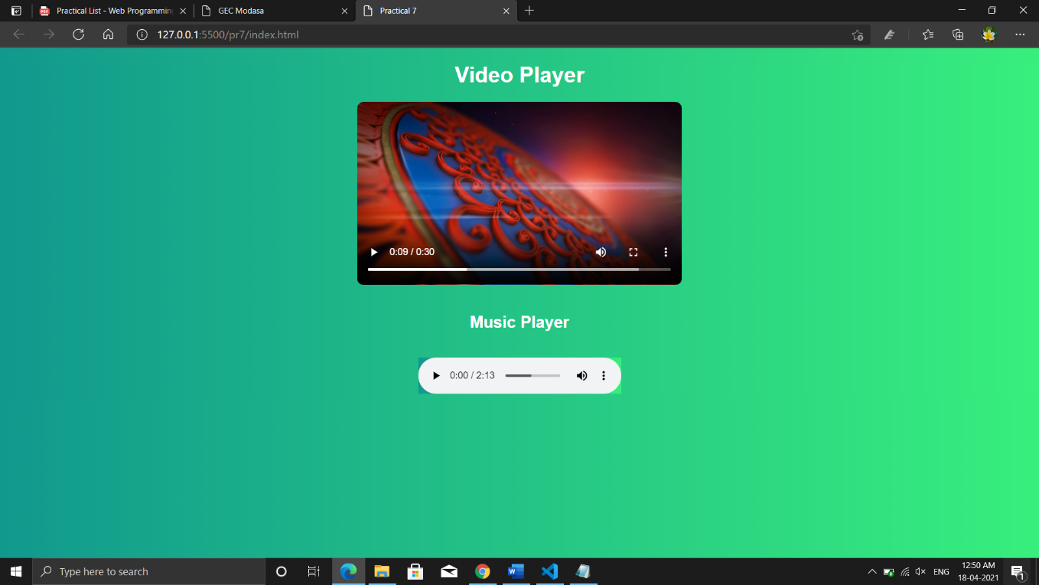

**Practical-8**

**Aim:** Introduction to CSS. Demonstrate types of CSS with example.

CSS stands for Cascading Style Sheets.

CSS saves a lot of work. It can control the layout of multiple web pages all at once.

# CSS = Styles and Colors

Manipulate Text

Colors,  Boxes

## What is CSS?

Cascading Style Sheets (CSS) is used to format the layout of a webpage.

With CSS, you can control the color, font, the size of text, the spacing between elements, how elements are positioned and laid out, what background images or background colors are to be used, different displays for different devices and screen sizes, and much more!

## Using CSS

CSS can be added to HTML documents in 3 ways:

* **Inline** - by using the style attribute inside HTML elements
* **Internal** - by using a <style> element in the <head> section
* **External** - by using a <link> element to link to an external CSS file

The most common way to add CSS, is to keep the styles in external CSS files. However, in this tutorial we will use inline and internal styles, because this is easier to demonstrate, and easier for you to try it yourself.

## Inline CSS

An inline CSS is used to apply a unique style to a single HTML element.

An inline CSS uses the style attribute of an HTML element.

The following example sets the text color of the <h1> element to blue, and the text color of the <p> element to red:

### **Example**

<!DOCTYPE html>

<html>

<body>

<h1 style="color:blue;">A Blue Heading</h1>

<p style="color:red;">A red paragraph.</p>

</body>

</html>

**Output:**

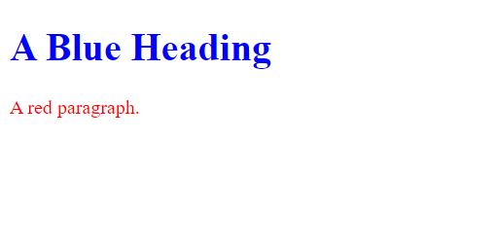

## Internal CSS

An internal CSS is used to define a style for a single HTML page.

An internal CSS is defined in the <head> section of an HTML page, within a <style> element.

The following example sets the text color of ALL the <h1> elements (on that page) to blue, and the text color of ALL the <p> elements to red. In addition, the page will be displayed with a "powderblue" background color:

### **Example**

<!DOCTYPE html>  
<html>  
<head>  
<style>  
body {background-color: powderblue;}  
h1   {color: blue;}  
p    {color: red;}  
</style>  
</head>  
<body>  
  
<h1>This is a heading</h1>  
<p>This is a internal css.</p>  
  
</body>  
</html>

Output:



## External CSS

An external style sheet is used to define the style for many HTML pages.

To use an external style sheet, add a link to it in the **<head>** section of each HTML page:

### **Example**

<!DOCTYPE html>  
<html>  
<head>  
  <link rel="stylesheet" href="styles.css">  
</head>  
<body>  
  
<h1>This is a heading</h1>  
<p>This is a paragraph.</p>  
  
</body>  
</html>

The external style sheet can be written in any text editor. The file must not contain any HTML code, and must be saved with a .css extension.

Here is what the "styles.css" file looks like:

**"styles.css":**

body {  
  background-color: powderblue;  
}  
h1 {  
  color: blue;  
}  
p {  
  color: red;

}

Output:

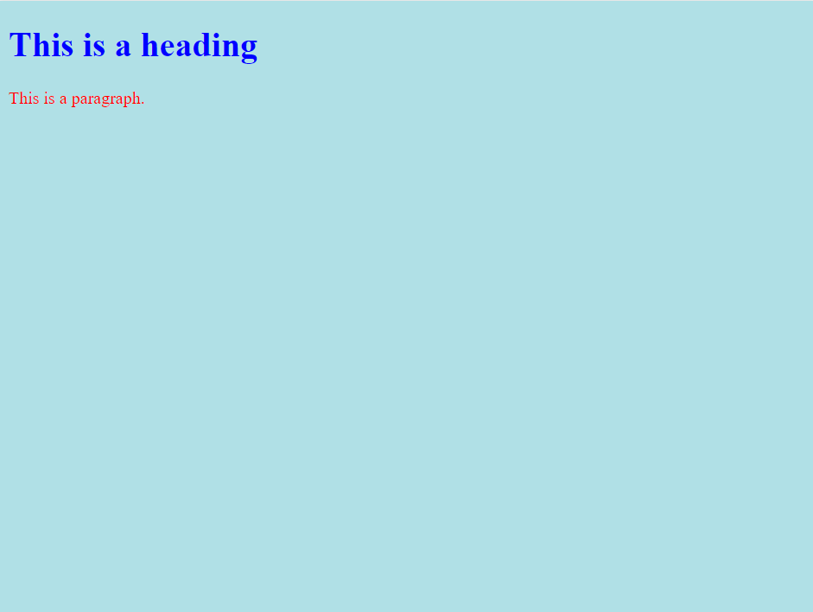

**Practical-9**

**Aim:** Demonstrate the following attributes using CSS ● Colour and background ● Font ● Text ● Border ● Margin and list

**Code:**

<!DOCTYPE html>

<html lang="en">

<head>

<meta charset="UTF-8" />

<title>Practical 9</title>

<style>

.std {

height: 175px;

width: 300px;

}

</style>

</head>

<body style="background-color: palevioletred;">

<div style="float: left">

<h1>Color and background</h1>

<table class="std">

<tr>

<td style="border: 1px solid; border-color: blue">border color</td>

<td style="background-color: aqua">background color</td>

<td style="color: cadetblue">Text color</td>

</tr>

<tr>

<td style="background-color: rebeccapurple">background color</td>

<td style="backgroundcolor: rebeccapurple; opacity: 0.5">

background color with low opacity

</td>

<td style=" background: url('01.jpg');background-repeat: norepeat;background-size: contain;">

background img

</td>

</tr>

</table>

</div>

<div style="float: left; margin-left: 20px">

<h1>Font</h1>

<div style="float: left; margin-left: 1px">

<table>

<h3>Font family</h3>

<tr>

<td style="font-family: serif">This is serif</td>

</tr>

<tr>

<td

style="

fontfamily: 'Lucida Sans', 'Lucida Sans Regular',

'Lucida Grande', 'Lucida Sans Unicode';

"

>

This is luscida

</td>

</tr>

<tr>

<td style="font-family: Arial, Helvetica, sansserif">

This is Arial

</td>

</tr>

<tr>

<td style="fontfamily: 'Times New Roman', Times, serif">

Times new Roman

</td>

</tr>

</table>

</div>

<div style="float: left; margin-left: 1px">

<table style="border: 1px solid black; border-collapse: collapse">

<h3>Font: Style, Weight and varient</h3>

<tr>

<th>Style</th>

<th>Weight</th>

<th>Varient</th>

</tr>

<tr>

<td style="font-style: normal; border: 1px solid black">normal</td>

<td style="font-weight: normal; border: 1px solid black">normal</td>

<td style="fontvariant: normal; border: 1px solid black">normal</td>

</tr>

<tr>

<td style="font-style: italic; border: 1px solid black">italic</td>

<td style="font-weight: bold; border: 1px solid black">Bold</td>

<td style="font-variant: small-caps; border: 1px solid black">

smallcaps

</td>

</tr>

<tr>

<td style="font-style: oblique; border: 1px solid black">

oblique

</td>

<td style="font-style: oblique; border: 1px solid black"></td>

<td style="font-style: oblique; border: 1px solid black"></td>

</tr>

</table>

</div>

</div>

<div style="float: left; margin-left: 20px">

<div style="float: left; margin-left: 1px">

<h1>Text</h1>

<h3>Text Color</h3>

<table>

<tr height="50px" style="border: 1px solid black">

<th width="100px" style="color: red; border: 1px solid black">

Text co lor

</th>

<th

width="100px"

style="backgroundcolor: red; border: 1px solid black"

>

Background color

</th>

</tr>

</table>

<h3>Text Alignment</h3>

<table>

<tr height="50px" style="border: 1px solid black">

<th width="80px" style="textalign: center; border: 1px solid black">

center

</th>

<th width="80px" style="textalign: left; border: 1px solid black">

left

</th>

<th width="80px" style="textalign: right; border: 1px solid black">

right

</th>

</tr>

</table>

</div>

<div style="float: left; margin-left: 1px">

<h3>Text Decoration</h3>

<table>

<tr height="50px" style="border: 1px solid black">

<th

width="80px"

style="textdecoration: overline; border: 1px solid black"

>

Overline

</th>

<th

width="80px"

style="text-decoration: linethrough; border: 1px solid black"

>

Line-through

</th>

<th

width="80px"

style="textdecoration: underline; border: 1px solid black"

>

Underline

</th>

</tr>

</table>

<h3>Text Transformation</h3>

<table>

<tr height="50px" style="border: 1px solid black">

<th

width="80px"

style="texttransform: capitalize; border: 1px solid black"

>

capitalize

</th>

<th

width="80px"

style="texttransform: uppercase; border: 1px solid black"

>

uppercase

</th>

<th

width="80px"

style="texttransform: lowercase; border: 1px solid black"

>

lowercase

</th>

</tr>

</table>

</div>

</div>

<div style="float: left; margin-left: 1px; margin-top: 1px">

<h1>Border</h1>

<h3>Border Style</h3>

<table>

<tr height="50px" style="border: 1px solid black">

<th width="100px" style="border: 3px solid black">Solid</th>

<th width="100px" style="border: 3px dotted black">Dotted</th>

<th width="100px" style="border: 3px double black">Double</th>

</tr>

</table>

<h3>Border Color and Width</h3>

<table>

<tr height="50px" style="border: 1px solid black">

<th width="100px" style="border: 2px solid red">Solid</th>

<th width="100px" style="border: 4px solid blue">Dotted</th>

<th width="100px" style="border: 6px solid black">Double</th>

</tr>

</table>

</div>

<div style="float: left; margin-left: 20px; margin-top: 1px">

<h1>Margin and list</h1>

<div style="float: left; margin-left: 1px">

<h3>Margin</h3>

<table>

<tr height="100px" style="border: 1px solid black">

<th width="90px" style="border: 1px solid black">

<p style="margin-top: 40px">top</p>

</th>

<th width="90px" style="border: 1px solid black">

<p style="margin-bottom: 40px">bottom</p>

</th>

<th width="90px" style="border: 1px solid black">

<p style="margin-left: 40px">left</p>

</th>

<th width="90px" style="border: 1px solid black">

<p style="margin-right: 40px">right</p>

</th>

</tr>

</table>

</div>

<div style="float: left; margin-left: 10px">

<h3>List</h3>

<div

style="float: left;border: 1px solid black;marginleft: 1px;padding: 5px;">

<h5>Unordered List</h5>

<ul type="circle">

<li>Circle</li>

</ul>

<ul type="disc">

<li>disc</li>

</ul>

<ul type="square">

<li>square</li>

</ul>

</div>

<div

style="float: left;border: 1px solid black;marginleft: 1px; padding: 5px;">

<h5>Ordered List</h5>

<ol type="1">

<li>1</li>

</ol>

<ol type="i">

<li>i</li>

</ol>

<ol type="A">

<li>A</li>

</ol>

</div>

</div>

</div>

</body>

</html>

**Output:**

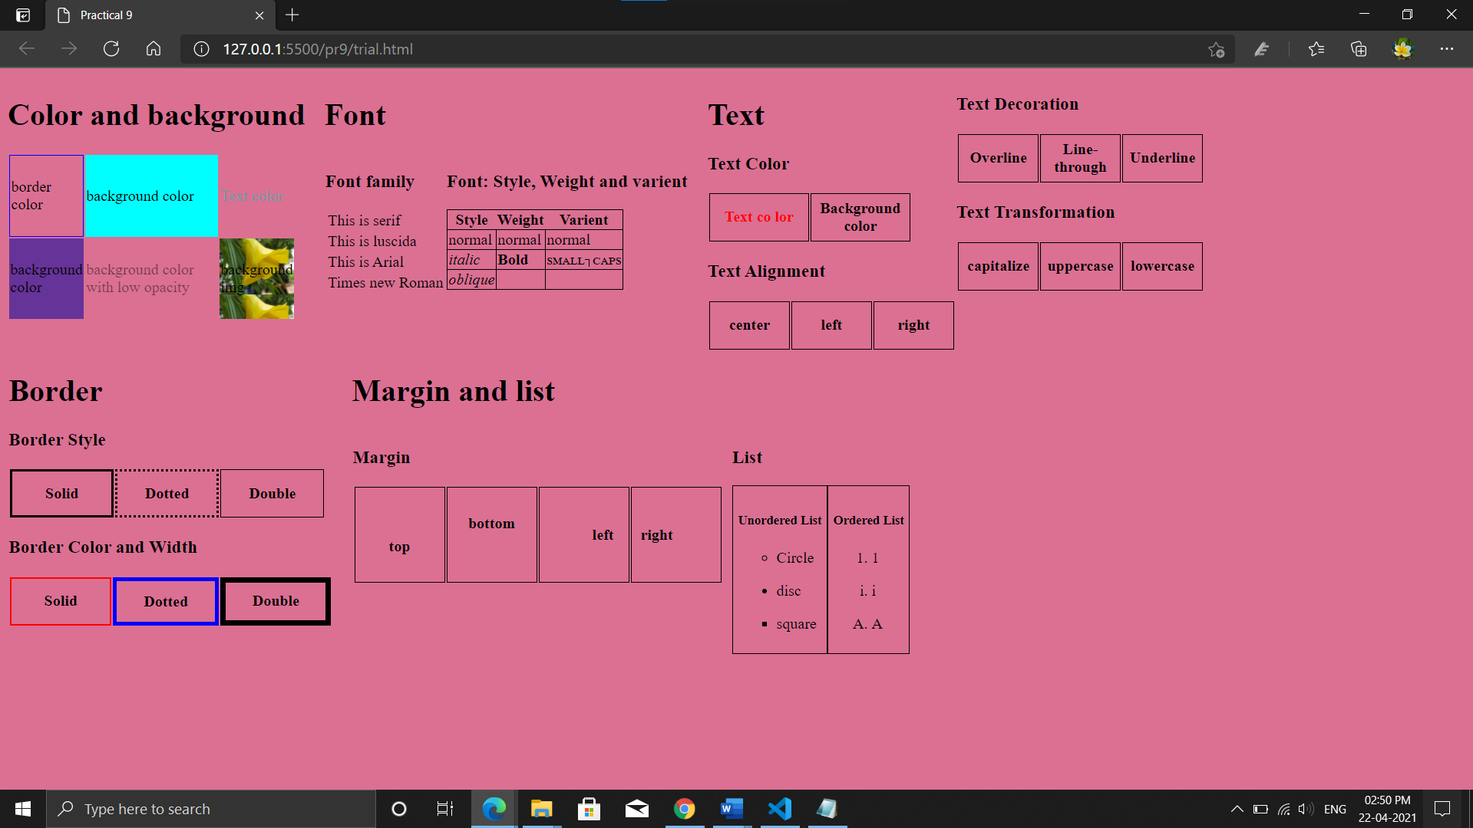

**Practical-10**

**Aim:** Create a Picture Book using HTML & External CSS.

**Code:**

<!DOCTYPE html>

<html lang="en">

<head>

<title>Picture Book</title>

<style>

body{

background: linear-gradient(90deg,#7d54a5,#667EEA,#ca1193);color: white;

font-family: "Montserrat", sans-serif;}

h1{text-align: center;background:linear-gradient(56deg,#434a69,#9b2778) ;border-radius: 5px;

padding: 5px;text-shadow: 2px 2px 4px #000000;}

.im img{width: 320px;box-shadow: 3px 3px 5px #000000;border-radius: 5px;}

.im{display: block;margin-left: auto;margin-right: auto;width: 65%;}

div{text-align: center;}

td{padding: 3px;}

.shd{box-shadow: 2px 2px 4px #000000;}

</style>

</head>

<body>

<div class="shd">

<h1>Picture Book</h1></div>

<div>

<table class="im">

<tr>

<td><img src="01.jpg" alt="No Image"></td>

<td><img src="02.jpg" alt="No Image"></td>

<td><img src="03.jpg" alt="No Image"></td>

</tr>

<tr>

<td><img src="04.jpg" alt="No Image"></td>

<td><img src="05.jpg" alt="No Image"></td>

<td><img src="06.jpg" alt="No Image"></td>

</tr>

<tr>

<td><img src="07.jpg" alt="No Image"></td>

<td><img src="08.jpg" alt="No Image"></td>

<td><img src="09.jpg" alt="No Image"></td>

</tr>

</table>

</div>

</body>

</html>

**Output:**

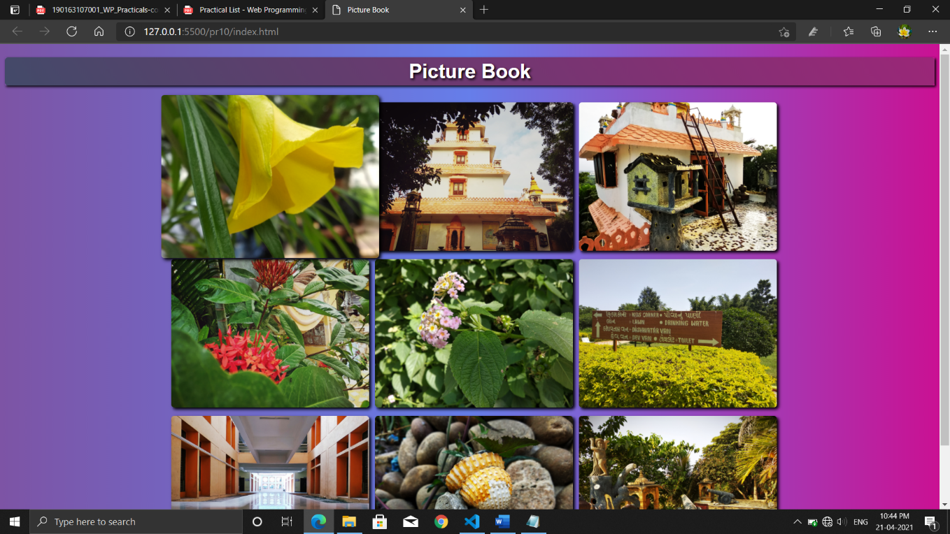

**Practical-11**

**Aim:** Design a web page of your home town with an attractive background colour, text, images, fonts etc, Using Internal CSS only.

**Code:**

<!DOCTYPE html>

<html lang="en">

<head>

<meta charset="UTF-8" />

<meta http-equiv="X-UA-Compatible" content="IE=edge" />

<meta name="viewport" content="width=device-width, initial-scale=1.0" />

<title>Junagadh-The city Of Lion</title>

<style>

body{

background: linear-gradient(90deg,#fc5d3d,#f82484);

color: white;

font-family: 'Montserrat', sans-serif;

}

h1{text-align: center;border-radius: 5px;box-shadow: 2px 2px 4px #000000;text-shadow: 1px 1px 3px #000000;;

background: linear-gradient(90deg,#c92404,#e40067); padding: 5px;}

img{width: 280px;border-radius: 5px;}

img:hover {

transition: transform 1s;

transform: scale(1.1);

opacity: 1;

box-shadow: 3px 3px 5px #000000;

}

</style>

</head>

<body>

<h1>Junagadh </h1>

<p>

Junagadh About this soundpronunciation is the headquarters of

Junagadh district in the Indian state of Gujarat. Located at the foot of

the Girnar hills, 355 kilometres (221 mi) southwest of Ahmedabad and

Gandhinagar (the state capital), it is the seventh largest city in the

state. Literally translated, Junagadh means "Old Fort". After a brief

struggle between India and Pakistan, Junagadh voted to join India in a

plebiscite held on 20 February 1948. It was a part of Saurashtra state and

later Bombay state. In 1960, in consequence of the Maha Gujarat movement,

it became part of the newly formed Gujarat state.

</p>

<img src="girnar.jpg" alt="">

<img src="makbaro.jpg" alt="">

<img src="girnarlake.jpg" alt="">

<img src="cloudGirnar.jpg" alt="" height="210px">

<img src="makbaro2.jpg" alt=""height="210px">

<br>

<h2>Girnar hills</h2>

<p>Girnar, also known as Girinagar or Revatak Parvata, is a group of mountains in

the Junagadh District of Gujarat, India, situated near Junagadh. Is considered

older than the Himalayas, Girnar, the mountain and its range are considered sacred.

It is an important pilgrimage site for both Hindus , who gather here during the Girnar

Parikrama festival. Later on some Jain temples were also built, some of which are very recent.

Girnar is one of the five major ‘tirthas’ attributed to the ‘panch kalyanakas’ of various ‘Jain tirthankaras’.

Girnar is also significant among Shiva devotees for the so-called “mystic space-time” of the mountain range, with

the presence and turnover of different sects of Sadhu Babas, Nath sect and others. Flora and fauna fairs are also

held at the mountains, such as the Maha Shivratri fair. Different Jain Tirthankaras and monks have in the past visited

and practiced severe penance at the peaks of Girnar. It hosts a number of temples and some historical spots across its range.</p>

<h2>Mahabat Maqbara</h2>

<p>Mahabat Maqbara Palace, also Mausoleum of Bahaduddinbhai Hasainbhai, is

a mausoleum in Junagadh, India, that was once home to the Muslims rulers

the Nawabs of Junagadh. The city of Junagadh has other 18th-century mausoleums

built by the nawabs in the area around Chitkana Chowk.</p>

<h2>Willingdon Dam</h2>

<p>The dam is built on the river Kalwa at the foot of the hill from where it originates. It was built as a reservoir for

drinking water for the people of Junagadh. It was named after Lord Willingdon, the then Governor of India. Near the dam,

the steps go up to 2,779 feet (847 m) high to the famous shrine of Jamiyal shah Datar, where both Hindu and Muslim devotees

share their faith.</p>

</body>

</html>

**Output:**

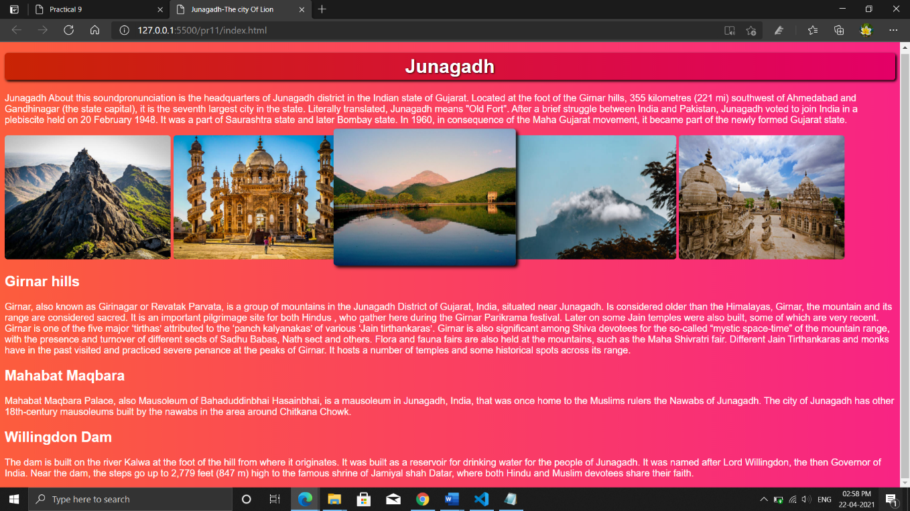

**Practical-12**

**Aim:** Write a program to print the date using JavaScript.

**Code:**

<!DOCTYPE html>

<html lang="en">

<head>

<meta charset="UTF-8">

<title>Practical 12</title>

</head>

<body>

<h1 id="date"></h1>

<script>

var date = new Date();

document.getElementById("date").innerHTML = date;

</script>

</body>

</html>

**Output:**

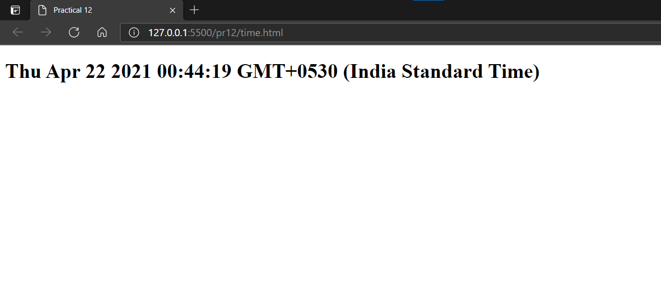

**Practical-13**

**Aim:** Write a program to create a simple calculator using JavaScript.

**Code:**

<!DOCTYPE html>

<html lang="en">

<head>

<meta charset="UTF-8">

<title>Practical 13</title>

<style>

body{background-color: blueviolet;

color: white;}

button{

height:60px;

width: 60px;

font-size:30px;

}

input[type="text"]{

height:50px;

width: 180px;

font-size:30px;

}

button{border-radius: 5px; color: purple;}

</style>

</head>

<body>

<center>

<h1>Calculator</h1>

<table>

<tr>

<td><button onclick="clr()">clr</button></td>

<td colspan="3"><input type="text" id="dis" disabled><br></td>

</tr>

<tr>

<td><button onclick="clik('+')">+</button></td>

<td><button onclick="clik('1')">1</button></td>

<td><button onclick="clik('2')">2</button></td>

<td><button onclick="clik('3')">3</button></td>

</tr>

<tr>

<td><button onclick="clik('-')">-</button></td>

<td><button onclick="clik('4')">4</button></td>

<td><button onclick="clik('5')">5</button></td>

<td><button onclick="clik('6')">6</button></td>

</tr>

<tr>

<td><button onclick="clik('*')">*</button></td>

<td><button onclick="clik('7')">7</button></td>

<td><button onclick="clik('8')">8</button></td>

<td><button onclick="clik('9')">9</button></td>

</tr>

<tr>

<td><button onclick="clik('/')">/</button></td>

<td><button onclick="clik('0')">0</button></td>

<td><button onclick="clik('10')">10</button></td>

<td><button onclick="sol()">=</button></td>

</tr>

</table>

</center>

<script>

function clik(val){

document.getElementById("dis").value += val;

}

function clr(){

document.getElementById("dis").value = "";

}

function sol(){

var data = document.getElementById("dis").value;

var ans = eval(data);

document.getElementById("dis").value = ans;

}

</script>

</body>

</html>

**Output:**

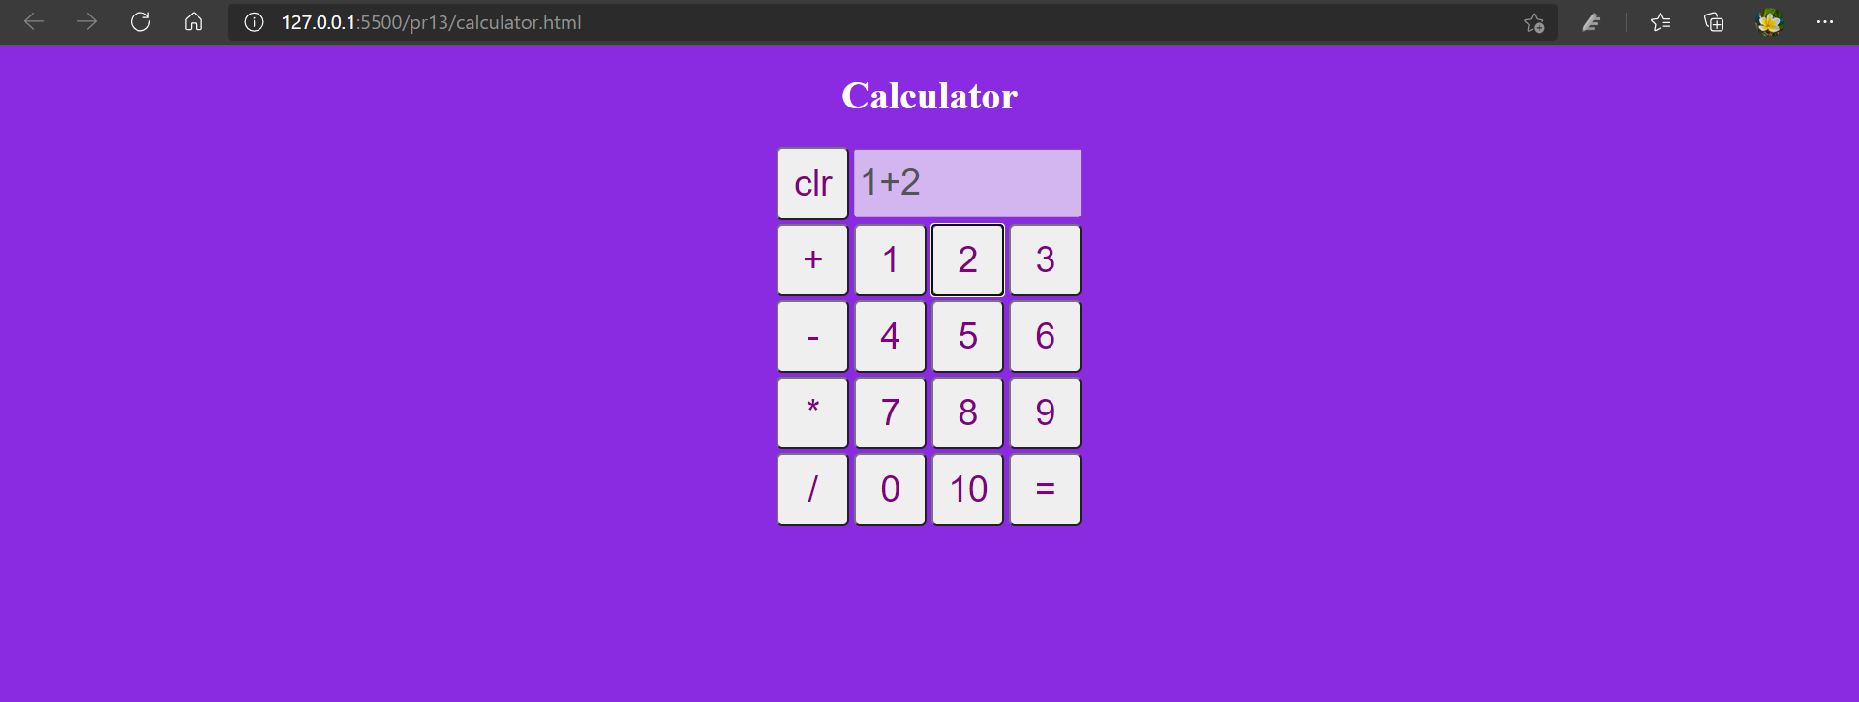

**Practical-14**

**Aim:** Write a program to show the use of alert, confirm and prompt box.

**Code:**

<!DOCTYPE html>

<html lang="en">

<head>

<meta charset="UTF-8">

<title>Practical 14</title>

</head>

<body>

<script>

if (confirm("Do you want to display your name?") == true)

{

alert("Very Good");

}

else

{

alert("You will have to.");

}

var name = prompt("Please enter your name:");

if (name != null)

{

alert("Welcome " + name);

}else{

alert("you have got no name.");

}

</script>

</body>

</html>

**Output:**

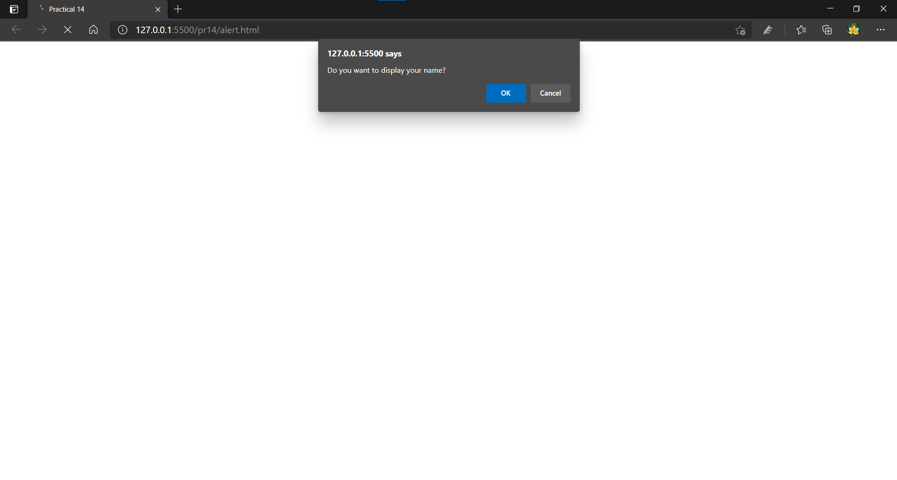

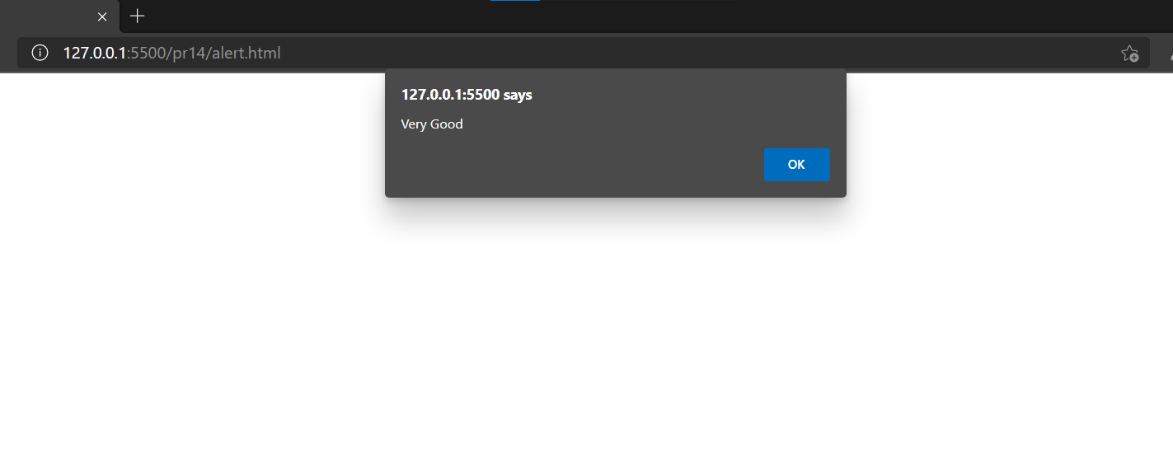

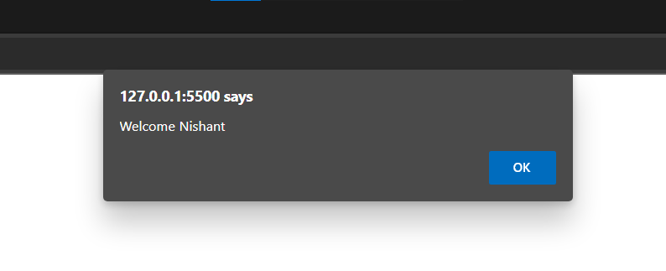

**Practical-15**

**Aim:** Write a program to validate HTML form data using JavaScript. (Name, Age, Mobile No.)

**Code:**

<!DOCTYPE html>

<html lang="en">

<head>

<meta charset="UTF-8">

<title>Practical 15</title>

<style>

body{background-color: dodgerblue;}

</style>

</head>

<body>

<div style="margin-top:20%; font-size: 20px;">

<center>

<form onsubmit="return onConfirm()" target="_blank" id="myform">

<table>

<tr>

<td><label for="name">Enter name: </label></td>

<td><input type="text" name="name" id="name"><br></td>

</tr>

<tr>

<td><label for="age">Enter age: </label></td>

<td><input type="number" name="" id="age" name="age"><br></td>

</tr>

<tr>

<td><label for="mno">Enter Mobile No.:</label></td>

<td><input type="tel" name="mno" id="mno" onkeypress="return isNum(event)"><br></td>

</tr>

<tr style="border: 1px solid red;">

<td colspan="2" style="textalign: center;"><input type="submit" value="Submit"></td>

</tr>

</table>

</form>

</center>

</div>

<script>

function isNum(event) {

var msg = document.getElementById('mno').value;

var keycode = (event.which) ? event.which : event.keycode

if (keycode != 46 && keycode > 31 && (keycode < 48 || keycode > 57)) {

alert("mobile number can accept only digits");

return false;

} else {

return true;

}

return true;

}

function onConfirm() {

var name = document.getElementById('myform').elements[0].value;

var age = document.getElementById('myform').elements[1].value;

var mobile = document.getElementById('myform').elements[2].value;

if (name == "") {

window.alert("Please enter your name");

document.getElementById("name").focus();

return false;

}

if (age == "") {

window.alert("Please enter your age");

document.getElementById("age").focus();

return false;

}

if (mobile == "") {

window.alert("Please enter your mobile");

document.getElementById("mno").focus();

return false;

}

if (age == 0 && age > 200) {

window.alert("Please enter your valid age");

document.getElementById("age").focus();

return false;

}

if (mobile.length != 10) {

window.alert("Please enter your valid mobile");

document.getElementById("mno").focus();

return false;

}

return true;

}

</script>

</body>

</html>

**Output:**

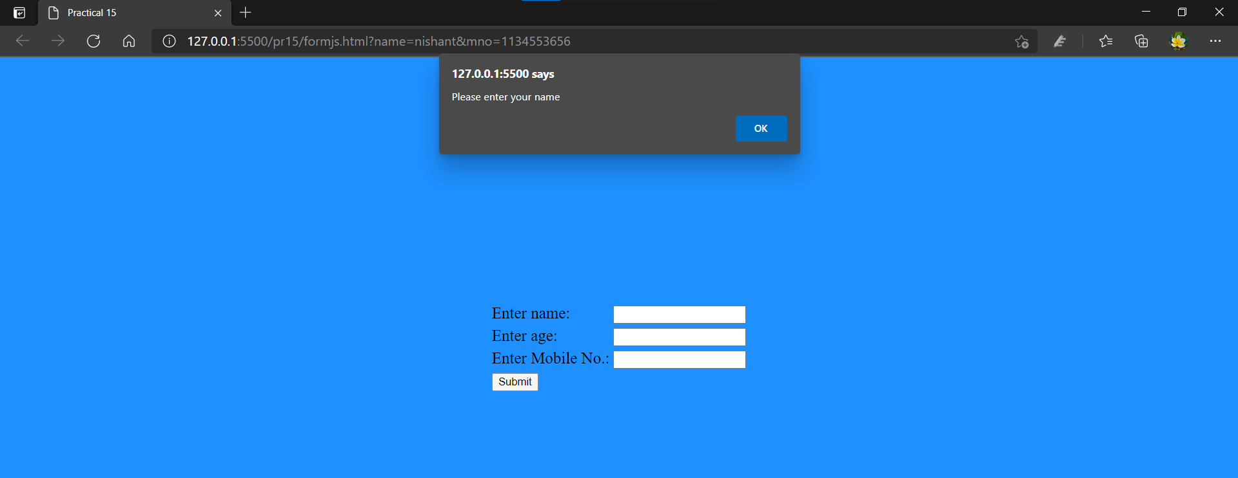

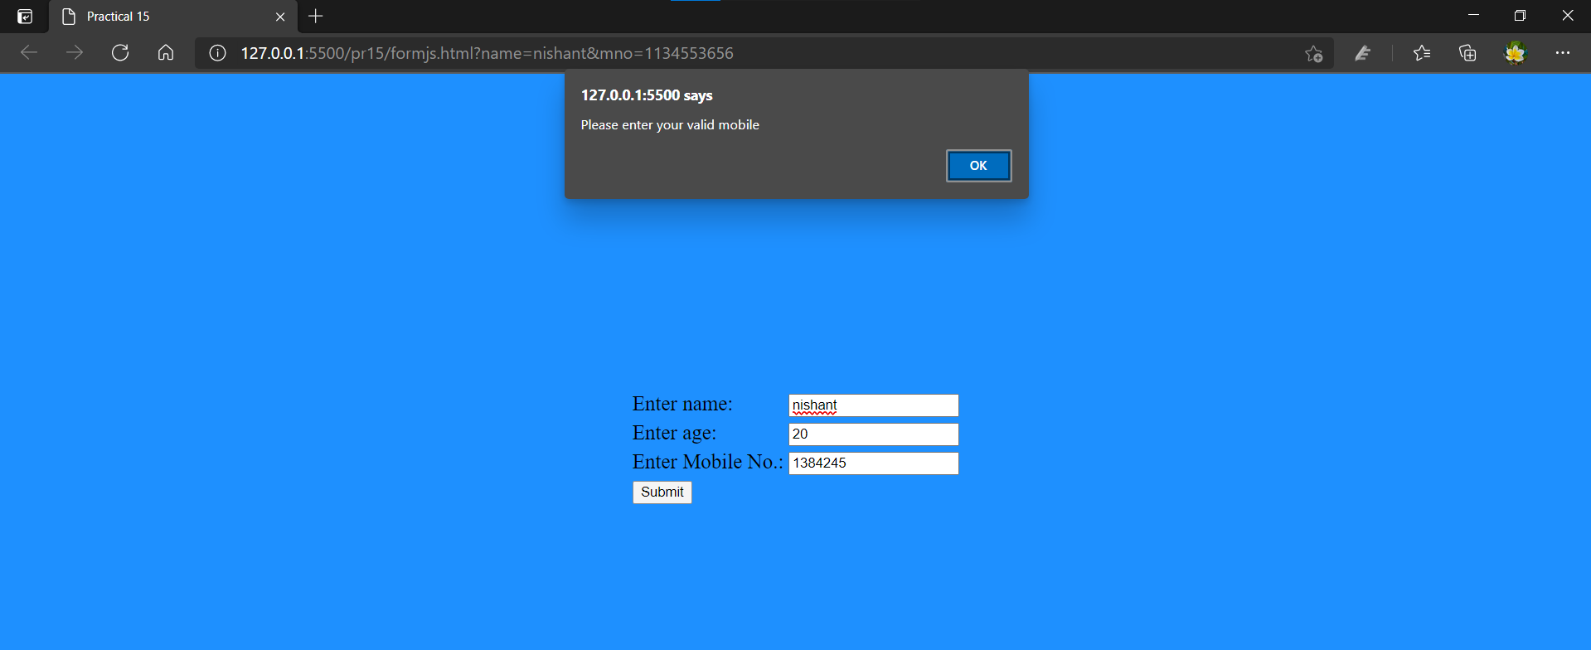

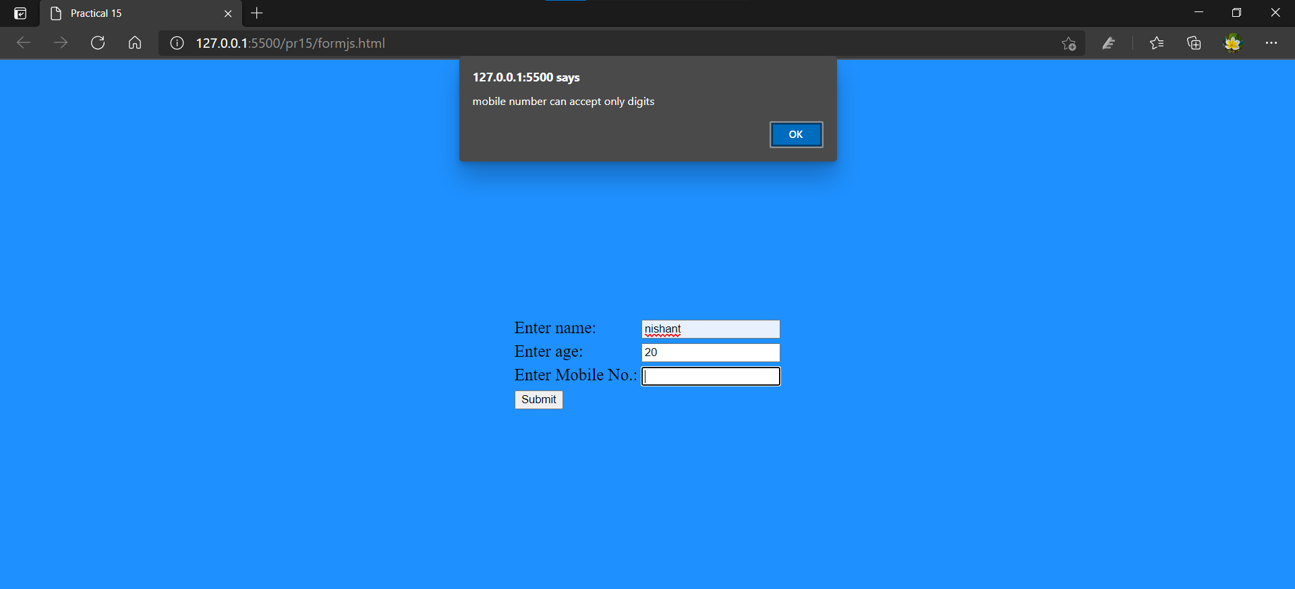

**Practical-16**

**Aim:** Write a program to validate practical-15’s HTML form using regular expression in JavaScript.

**Code:**

<!DOCTYPE html>

<html lang="en">

<head>

<meta charset="UTF-8">

<title>Practical 16</title>

<style>

body{background-color: dodgerblue;}

</style>

</head>

<body>

<div style="margin-top:20%; font-size: 20px;">

<center>

<form onsubmit="return onConfirm()" target="_blank" id="myform">

<table>

<tr>

<td><label for="name">Enter name: </label></td>

<td><input type="text" name="name" id="name"><br></td>

</tr>

<tr>

<td><label for="age">Enter age: </label></td>

<td><input type="number" name="" id="age" name="age"><br></td>

</tr>

<tr>

<td><label for="mno">Enter Mobile No.:</label></td>

<td><input type="tel" name="mno" id="mno" onkeypress="return isNum(event)"><br></td>

</tr>

<tr style="border: 1px solid red;">

<td colspan="2" style="textalign: center;"><input type="submit" value="Submit"></td>

</tr>

</table>

</form>

</center>

</div>

<script>

function isNum(event) {

var msg = document.getElementById('mno').value;

var keycode = (event.which) ? event.which : event.keycode

if (keycode != 46 && keycode > 31 && (keycode < 48 || keycode > 57)) {

alert("mobile number can accept only digits");

return false;

} else {

return true;

}

return true;

}

function onConfirm() {

var name = document.getElementById('myform').elements[0].value;

var age = document.getElementById('myform').elements[1].value;

var mobile = document.getElementById('myform').elements[2].value;

var regex = /^[a-zA-Z]+$/;

var regexMobile = /^([+]\d{2})?\d{10}$/;

var regexage = /^(0?[1-9]|[1-9][0-9]|[1][0-9][0-9]|200)$/;

if (name == "") {

window.alert("Please enter your name");

document.getElementById("name").focus();

return false;

}

if (age == "") {

window.alert("Please enter your age");

document.getElementById("age").focus();

return false;

}

if (mobile == "") {

window.alert("Please enter your mobile");

document.getElementById("mno").focus();

return false;

}

if (regex.test(name) == false) {

alert("Name must be in alphabets only");

document.getElementById("name").focus();

return false;

}

if (regexage.test(age) == false) {

window.alert("Please enter your valid age");

document.getElementById("age").focus();

return false;

}

if (regexMobile.test(mobile) == false){

alert("Please enter valid mobile number");

document.getElementById("mno").focus();

return false;

}

return true;

}

</script>

</body>

</html>

**Output:**

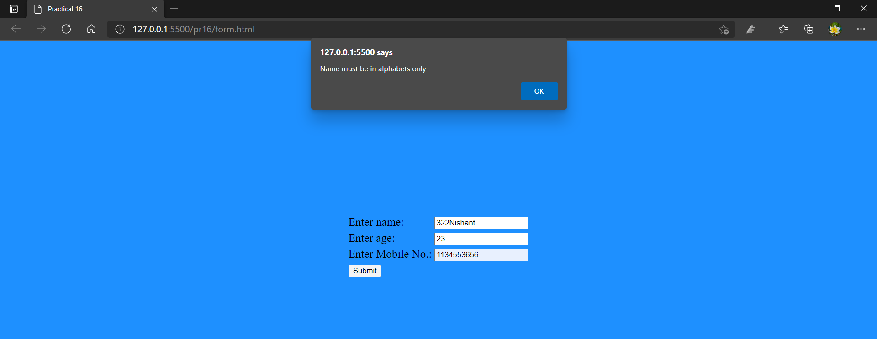

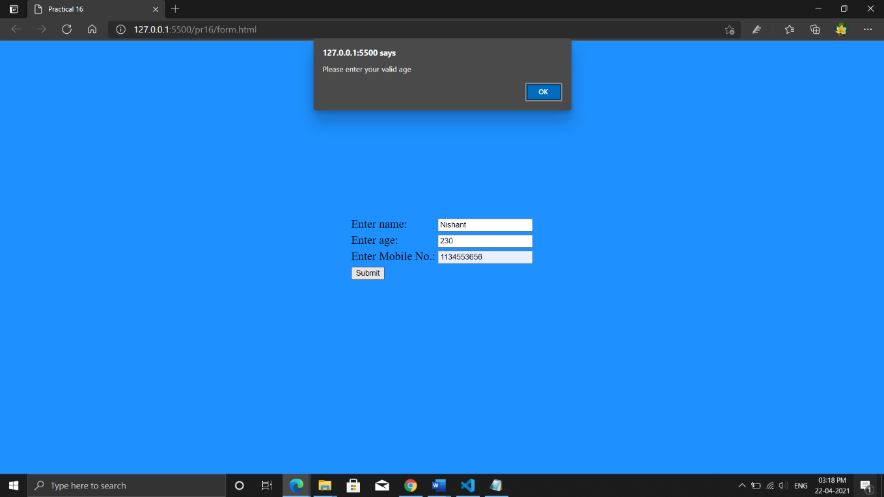

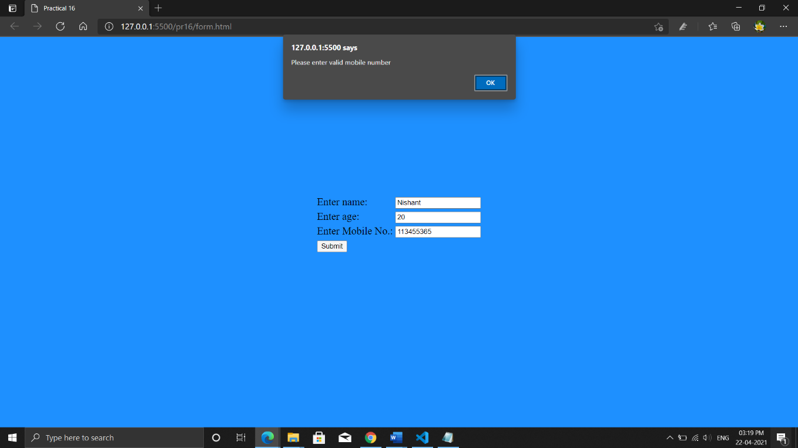

**Practical-17**

**Aim:** Write a PHP script to display today’s date in dd-mm-yyyy format.

**Code:**

<html>

<body>

<?php

echo"Today is ".date("Y-m-d")."<br>";

echo"Today is ".date("d/m/Y"). "<br>";

echo"Today is ".date("l"). "<br>";

?>

</body>

</html>

**Output:**

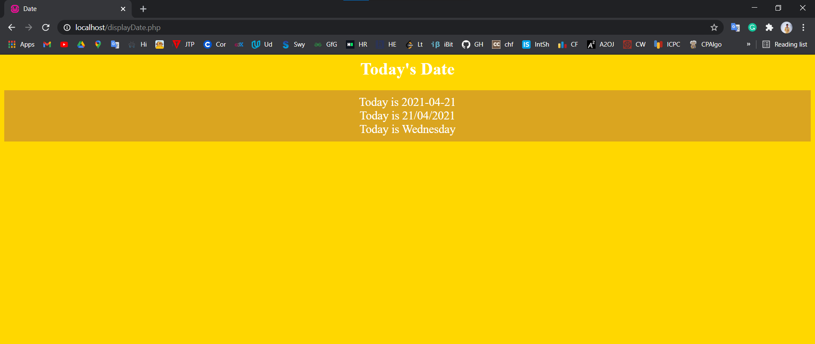

**Practical-18**

**Aim:** Write a PHP script to check if the number is prime or not.

**Code:**

<html>

<head>

<title>Prime Number</title>

</head>

<body style="background-color:dodgerblue;color:white;font-size:24px">

<?php

function isPrime($num){

if($num<=1){

return 0;

}

for($i=2; $i<=$num/2;$i++){

if($num%$i == 0){

return 0;

}

}

return 1;

}

$num = 23;

$flag = isPrime($num);

if($flag == 1){

echo"$num is Prime Number.";

}else {

echo"$num is not Prime Number.";

}

?>

</body>

</html>

**Output:**

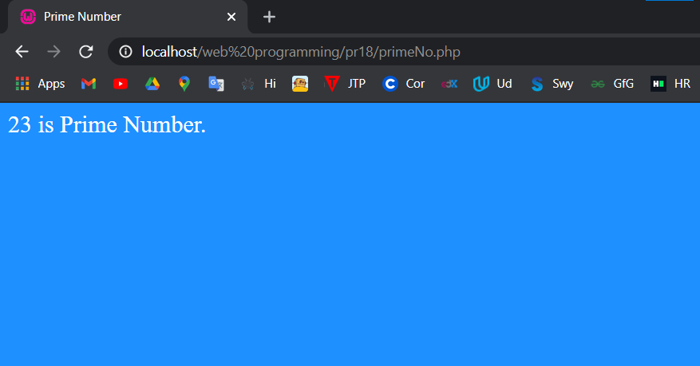

**Practical-19**

**Aim:** Write a PHP script to print the first 10 Fibonacci Numbers.

**Code:**

<!DOCTYPE html>

<html lang="en">

<head>

<title>Fibbonacci</title>

</head>

<body style="background-color:dodgerblue;color:white;font-size:24px;text-align:center;">

<h1>Fibbonacci</h1>

<?php

$num1 =1;

$num2 =1;

$ans = 0;

echo "1<br>";

for ($i=1; $i <= 10 ; $i++) {

$ans = $num1 + $num2;

echo $ans,"<br>";

$num1 =$num2;

$num2 = $ans;

}

?>

</body>

</html>

**Output:**

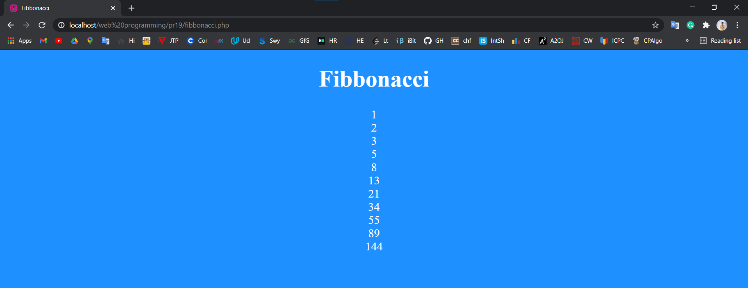

**Practical-20**

**Aim:** Create HTML page that contain textbox, submit / reset button. Write a PHP script to display this information and also store it into a text file.

**Code:**

**Form.html**

<html>

<body style="background-color:dodgerblue;color:white;font-size:24px;text-align;center;">

<form action="display" method="POST">

<label for="text">Enter a text:</label>

<input type="text" name="text"><br><br>

<input type="submit" name="submit" value="submit">

<input type="reset" name="reset" value="reset">

</form>

</body>

</html>

**Output:**

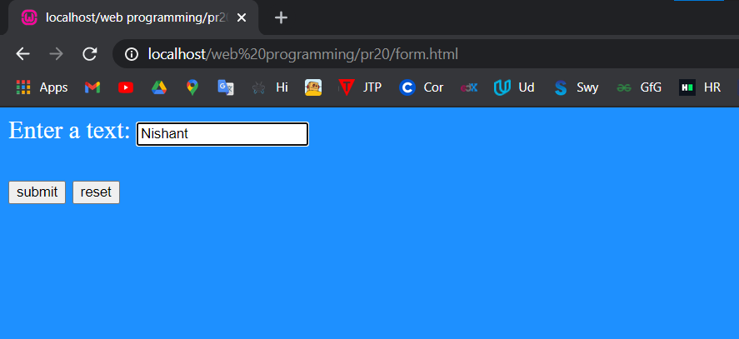

**Display.php**

<html>

<body style="background-color:dodgerblue;color:white;font-size:24px;text-align;center;">

<?php

if(isset($_POST["submit"])){

$text = $_POST["text"];

echo"$text";

$fp = fopen('data.txt','w');

fwrite($fp,$text);

fclose($fp);

echo"<br>Data store or Overwrite in text file. ";

}

?>

</body>

</html>

**Output:**

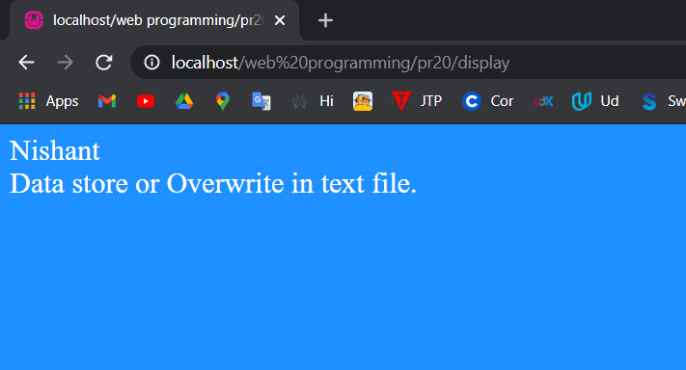

**Data.txt**

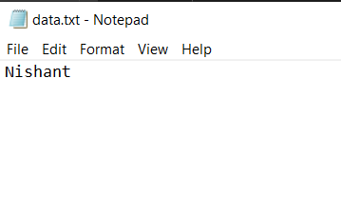

**Practical-21**

**Aim:** Create Login Page with HTML, PHP & MySql. (On Successful login it should display a successful message or in case of failure it should display an unsuccessful message.)

**Code:**

**Login.html**

<!DOCTYPE html>

<html lang="en">

<head>

<meta charset="UTF-8">

<meta http-equiv="X-UA-Compatible" content="IE=edge">

<meta name="viewport" content="width=device-width, initial-scale=1.0">

<title>Login Page</title>

<link rel="stylesheet" href="form.css">

</head>

<body>

<center>

<h1>Login Page</h1>

<div class="frm">

<form action="Authentication" method="POST">

Email: <input type="email" name="email" value="" ><br><br>

Password: <input type="password" name="password" value=""><br><br>

<input type="submit" name="login" value="Login" class="bt"><br><br>

<a href="Signup.html" class="lnk">Create a new account</a>

</form>

</div>

</center>

</body>

</html>

**Signup.html**

<!DOCTYPE html>

<html lang="en">

<head>

<meta charset="UTF-8">

<meta http-equiv="X-UA-Compatible" content="IE=edge">

<meta name="viewport" content="width=device-width, initial-scale=1.0">

<title>Signup Page</title>

<link rel="stylesheet" href="form.css">

</head>

<body>

<center>

<h1>Create Your Account</h1>

<div class="frm">

<form action="Authentication" method="POST">

Name : <input type="text" name="name" ><br><br>

Email : <input type="email" name="email"><br><br>

Password: <input type="password" name="password"><br><br>

<input type="submit" name="signup" value="Sign Up" class="bt"><br><br>

<a href="login.html" class="lnk">Already have an account?</a>

</form>

</div>

</center>

</body>

</html>

**Form.css**

body {

background: linear-gradient(90deg, rgb(12, 214, 204), blue);

color: white;

font-family: "Montserrat", sans-serif;

}

.frm {

height: 300px;

width: 300px;

border: 2px solid white;

padding: 20px;

background: linear-gradient(90deg, #9e1e64, #420ca5);

border-radius: 10px;

}

.bt {

padding: 5px;

background: linear-gradient(56deg, rgb(12, 214, 204), blue);

color: white;

border-radius: 4px;

border: 2px solid white;

padding-inline: 20px;

}

.bt:hover {

background: linear-gradient(56deg, blue, rgb(12, 214, 204));

}

input {

border-radius: 5px;

}

form {

padding: 10px;

}

.lnk{color: white;}

**Output:**

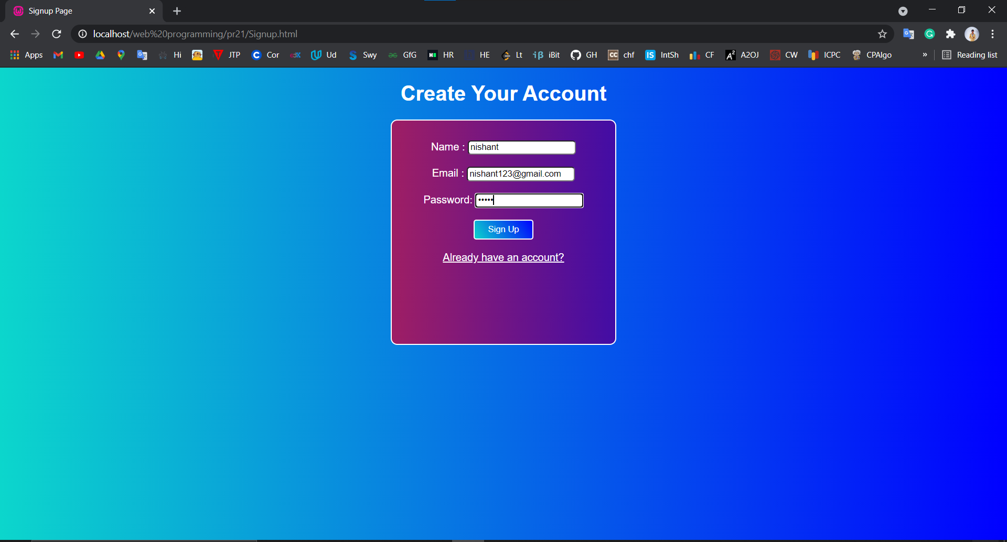

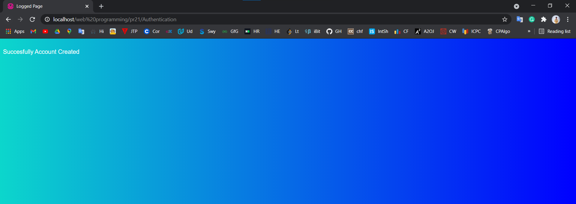

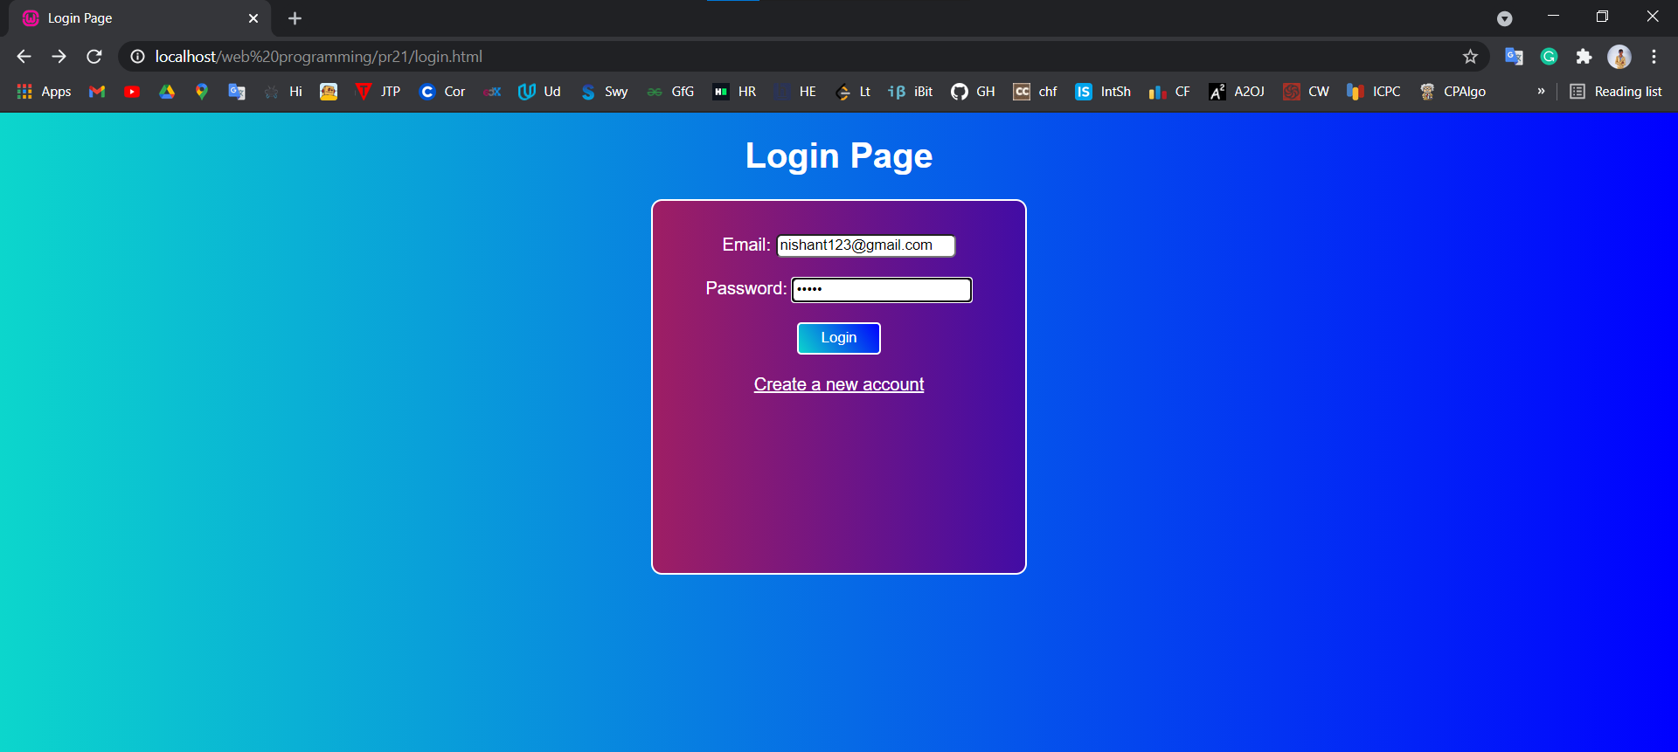

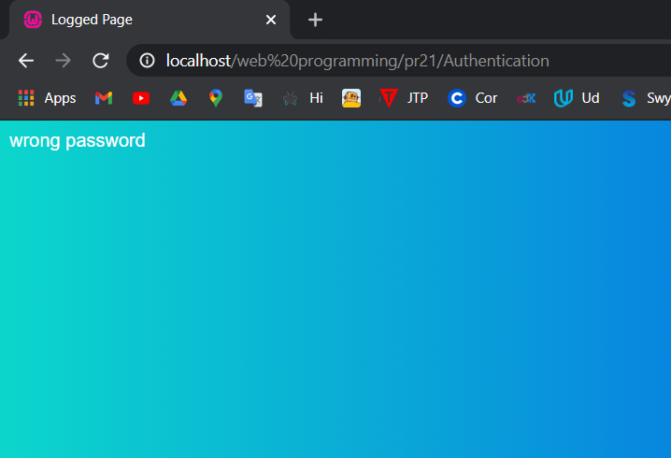

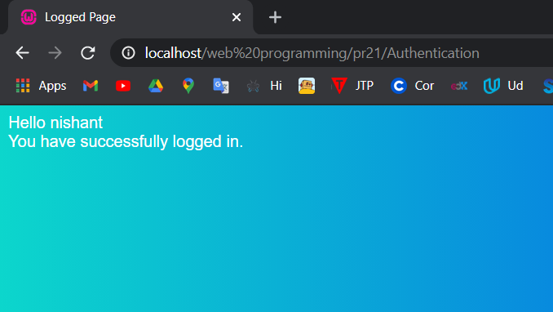

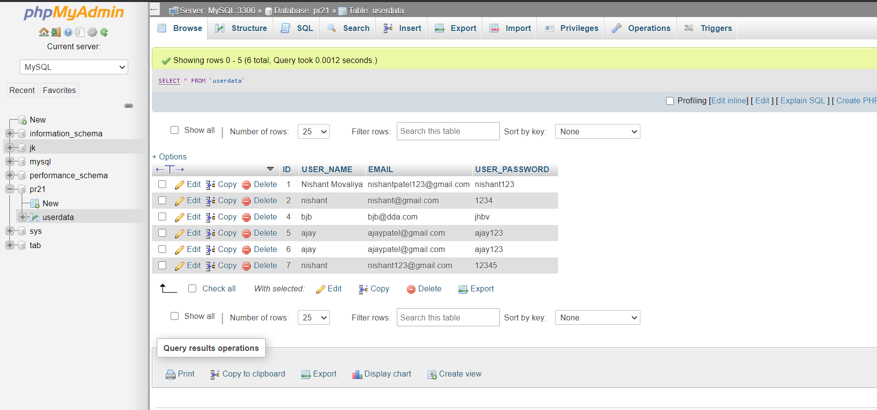

**Practical-22**

**Aim:** Display Students list (Name, Enrolment No, Branch and Email Address) and demonstrate Add, Update and Delete (CRUD) functionality using HTML, PHP & MySql.

**Code:**

**Index.html**

<!DOCTYPE html>

<html lang="en">

<head>

<meta charset="UTF-8">

<title>CRUD Operations</title>

<style>

body{

background: linear-gradient(90deg, #9e1e64, #420ca5); text-align: center;

color: white;}

</style>

</head>

<body>

<h3>Display data</h3>

<form action="display.php" method="post">

<input type="submit" value="Show data" name="display">

</form>

<h3>Insert Operations</h3>

<form action="insert.php" method="post">

ENROLL_NO: <input type="text" name="ENROLL_NO"><br><br>

NAME: <input type="text" name="NAME"><br><br>

BRANCH: <input type="text" name="BRANCH"><br><br>

EMAIL: <input type="text" name="EMAIL"><br><br>

<input type="submit" value="Insert" name="insert">

</form>

<br>

<h3>Update Operations</h3>

<form action="update.php" method="post">

ID: <input type="number" name="id"><br><br>

ENROLL_NO: <input type="text" name="ENROLL_NO"><br><br>

NAME: <input type="text" name="NAME"><br><br>

BRANCH: <input type="text" name="BRANCH"><br><br>

EMAIL: <input type="text" name="EMAIL"><br><br>

<input type="submit" value="Update" name="update"><br>

</form>

<br>

<h3>Delete Operations</h3>

<form action="delete.php" method="post">

ID: <input type="number" name="id"><br><br>

<input type="submit" value="Delete" name="delete">

</form>

</body>

</html>

**Output:**

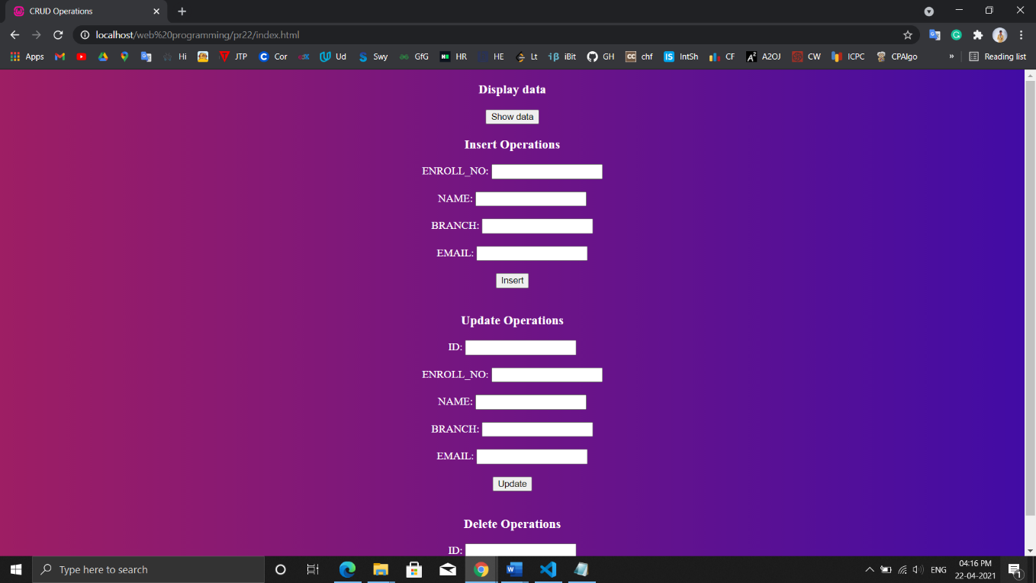

**Insert.php**

<?php

require 'connection.php';

if(isset($_POST['insert'])){

$ENROLL_NO = $_POST['ENROLL_NO'];

$NAME = $_POST['NAME'];

$BRANCH = $_POST['BRANCH'];

$EMAIL = $_POST['EMAIL'];

//insert data

$sql = "INSERT INTO STUDENT (ENROLL_NO , NAME, BRANCH, EMAIL)

VALUES ('$ENROLL_NO','$NAME','$BRANCH','$EMAIL')";

if(mysqli_query($conn, $sql)){

echo"<br> <h1>Data Inserted successfully.</h1>";

}else{

echo "<br>Error: ". mysqli_error($conn);

}

mysqli_close($conn);

}

?>

**Output:**

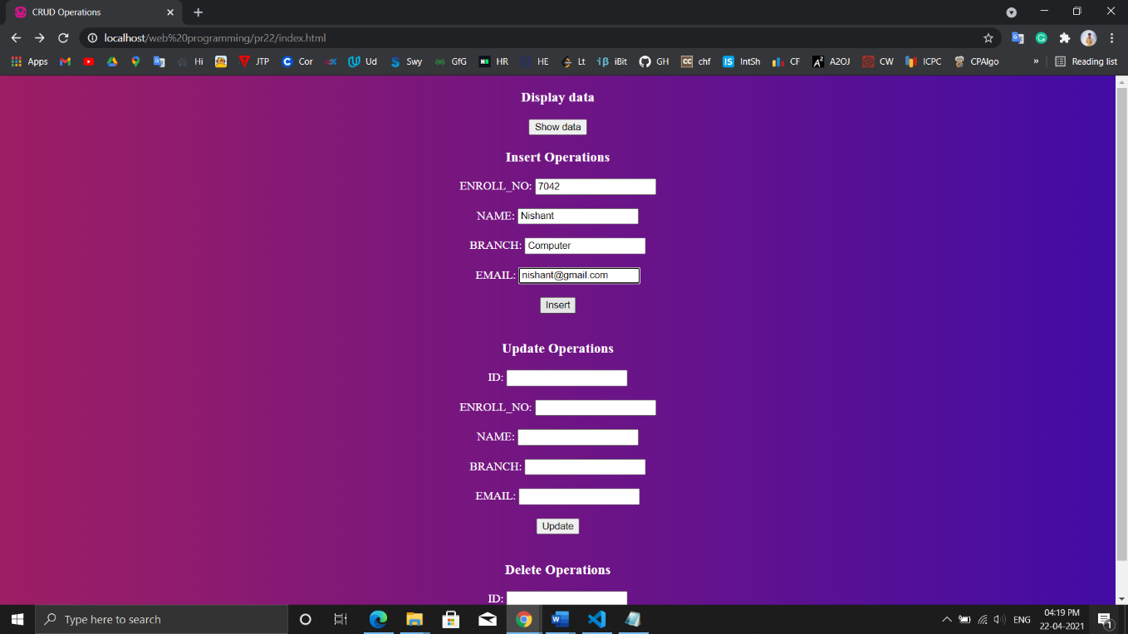

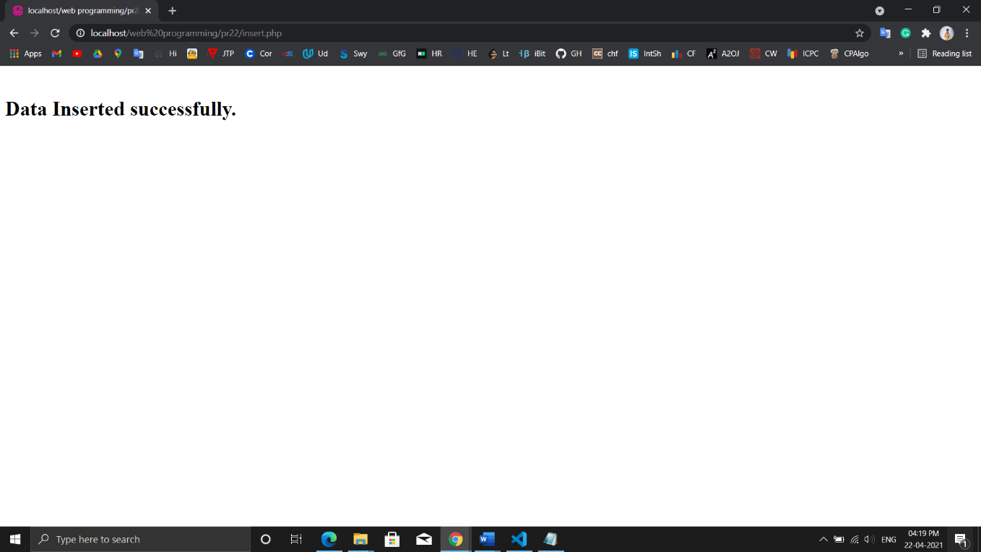

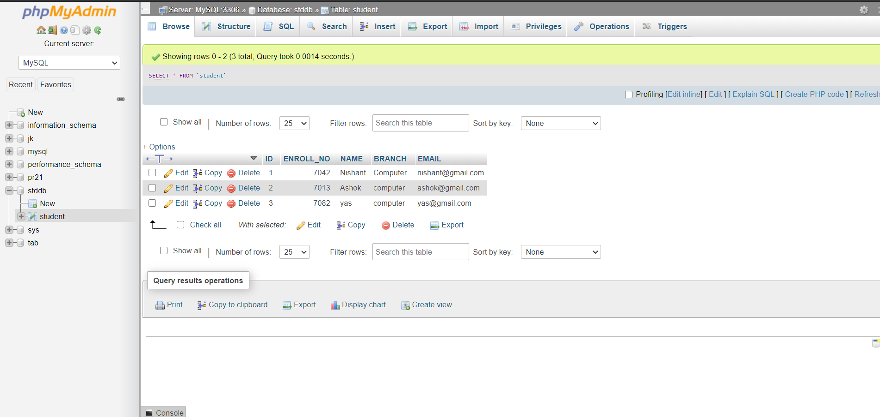

**Display.php**

<?php

include 'connection.php';

if (isset($_POST['display'])){

$sql = "SELECT * FROM STUDENT";

$result = mysqli_query($conn, $sql);

if (mysqli_num_rows($result) > 0) {

// output data of each row

echo "<h1>Student Records</h1>";

echo "<table style=\" border: 1px solid black; border-collapse: collapse;\">";

echo "<tr><th>ID</th><th>Enroll-no</th><th>Name</th><th>Branch</th><th>EmailId</th></tr>";

while($row = mysqli_fetch_assoc($result)) {

echo "<tr style=\" border: 1px solid black;\">";

foreach($row as $key => $value){

echo "<td style=\" border: 1px solid black;\">".$value."</td>";

}

echo "</tr>";

}//while

echo "</table>";

} else {

echo "<br>0 results";

}

mysqli_close($conn);

}

?>

**Output:**

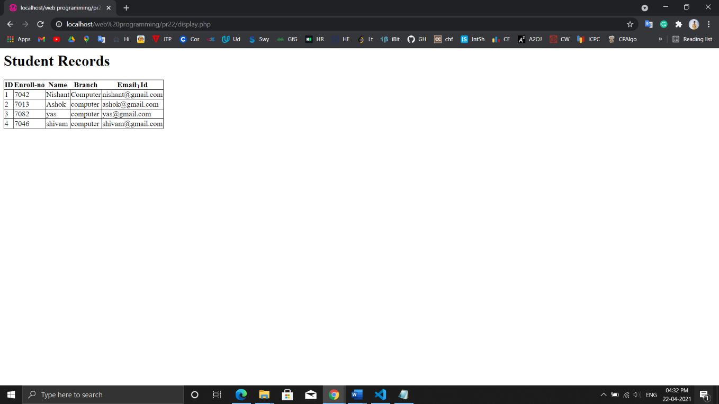

**Update.php**

<?php

include 'connection.php';

if(isset($_POST['update'])){

$id = $_POST['id'];

$ENROLL_NO = $_POST['ENROLL_NO'];

$NAME = $_POST['NAME'];

$BRANCH = $_POST['BRANCH'];

$EMAIL = $_POST['EMAIL'];

$sql = "UPDATE STUDENT SET ENROLL_NO = '$ENROLL_NO', NAME = '$NAME', BRANCH = '$BRANC

H', EMAIL = '$EMAIL' WHERE id = '$id' ";

if(mysqli_query($conn, $sql)) {

echo "<br>","<h1> Data Updated Successfully. </h1>";

}else{

echo "<br>Error: ". mysqli_error($conn);

}

mysqli_close($conn);

}

?>

**Output:**

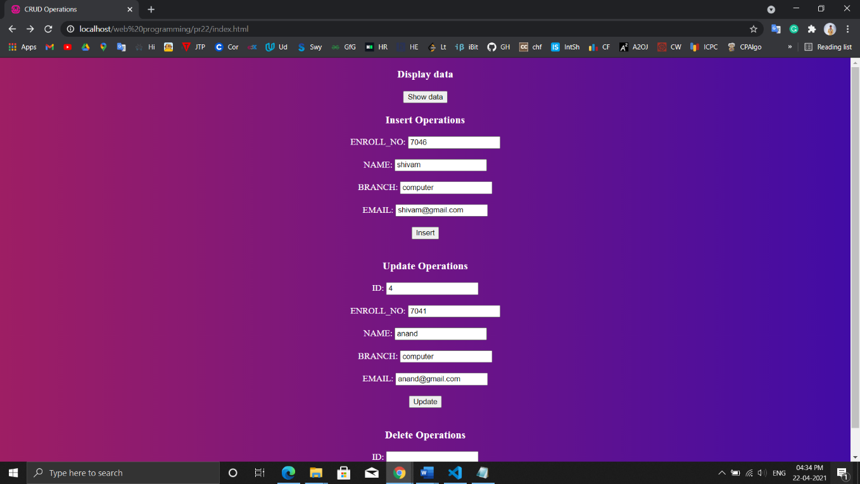

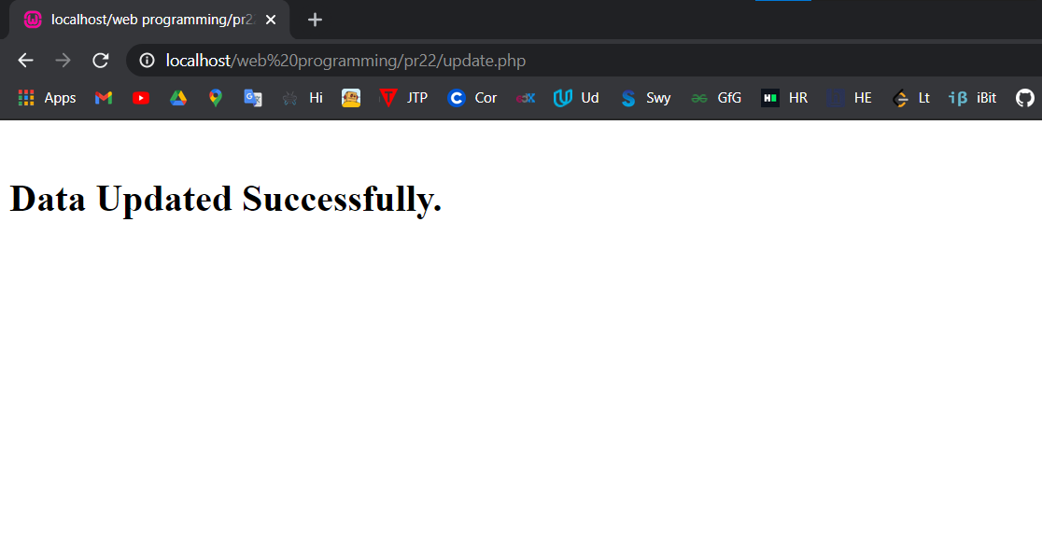

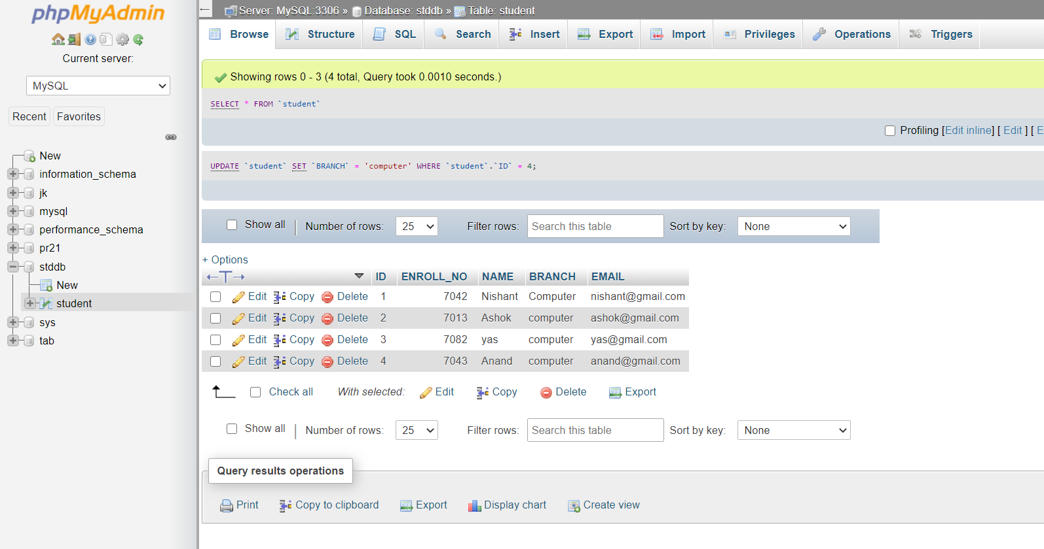

**Delete.php**

<?php

include 'connection.php';

if (isset($_POST['delete'])){

$id = $_POST['id'];

$sql = "DELETE FROM STUDENT WHERE ID = $id";

if(mysqli_query($conn, $sql)){

echo"<br><h1> Data Delete Successfully.</h1>";

}else{

echo "<br>Error: ". mysqli_error($conn);

}

mysqli_close($conn);

}

?>

**Output:**



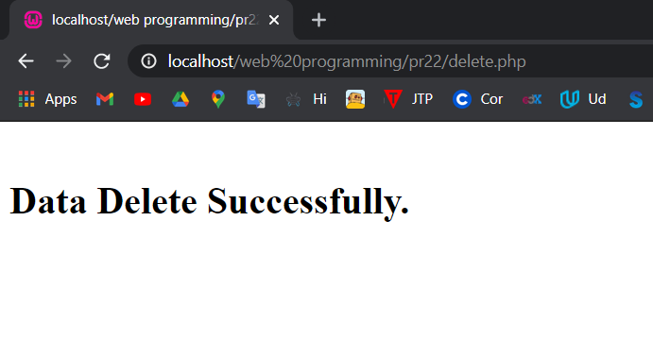

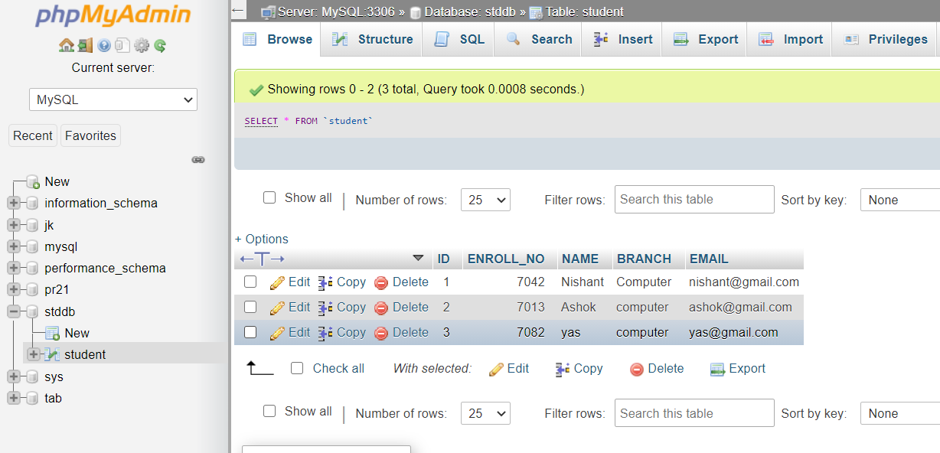

**Practical-23**

**Aim:** Using ajax retrieve data from a TEXT file and display it.

**Code:**

<!DOCTYPE html>

<html lang="en">

<head>

<meta charset="UTF-8">

<title>Practical 23</title>

</head>

<body>

<h1 id="show"></h1>

<button onclick="dislay();"> Show data</button>

<script>

function dislay(){

var xhttp = new XMLHttpRequest();

xhttp.onreadystatechange = function(){

if(this.readyState == 4 && this.status == 200){

document.getElementById("show").innerHTML = this.responseText;

}

};

xhttp.open("GET","data.txt",true);

xhttp.send();

}

</script>

</body>

</html>

**Output:**

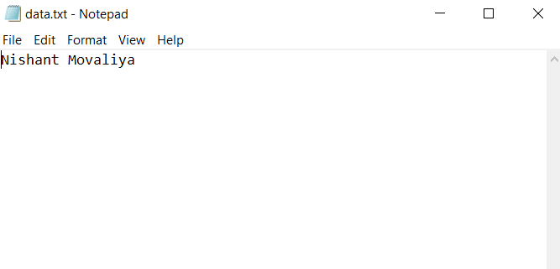

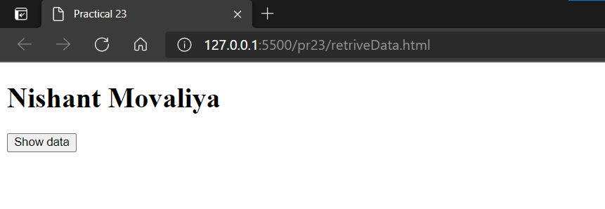

**Practical-24**

**Aim:** Retrieve customer information from the database and display it.

**Code:**

<!DOCTYPE html>

<html>

<head>

<style>

table,

th,

td {

border: 1px solid black;

border-collapse: collapse;

}

th,

td {

padding: 5px;

}

</style>

</head>

<body>

<h1>The XMLHttpRequest Object</h1>

<form action="">

<select name="customers" onchange="showCustomer(this.value)">

<option value="">Select a customer:</option>

<option value="ALFKI">AlfredsFutterkiste</option>

<option value="NORTS ">North/South</option>

<option value="WOLZA">WolskiZajazd</option>

</select>

</form>

<br>

<div id="txtHint">Customer info will be listed here...</div>

<script>

functionshowCustomer(str)

{

varxhttp;

if (str == "") {

document.getElementById("txtHint").innerHTML = "";

return;

}

xhttp = new XMLHttpRequest();

xhttp.onreadystatechange = function () {

if (this.readyState == 4 && this.status == 200) {

document.getElementById("txtHint").innerHTML = this.responseText;

}

};

xhttp.open("GET", "getcustomer.asp?q=" + str, true);

xhttp.send();

}

</script>

</body>

</html>

**Output:**

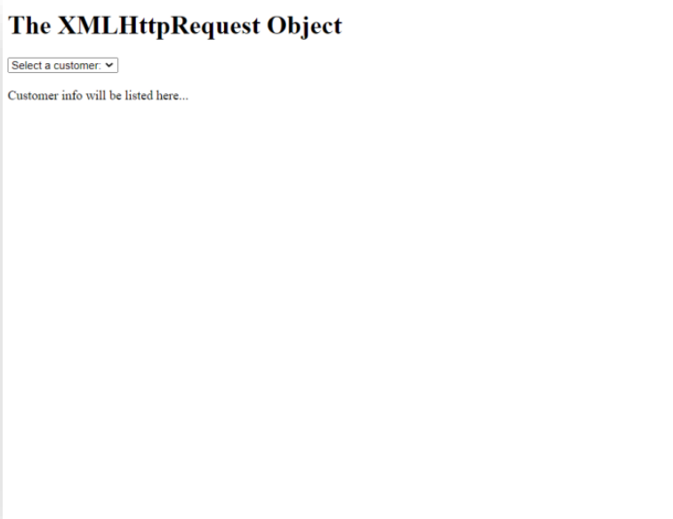

**Data Page**

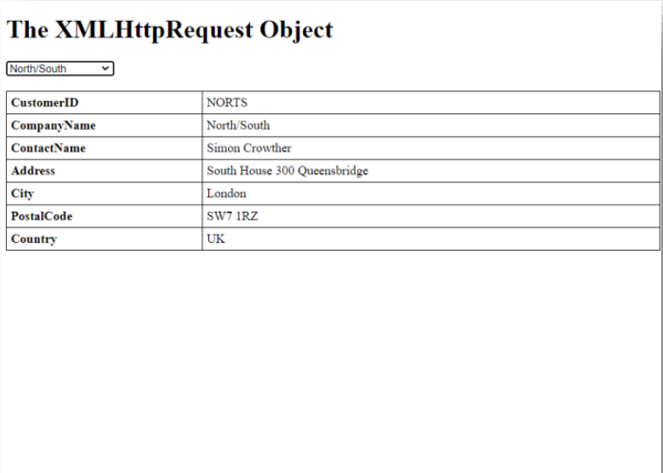

**Selected Data Page**

**Practical-25**

**Aim:** Create a Navigation Menu/Bar using JQuery.

**Code:**

<!DOCTYPE html>

<html>

<head>

<meta name="viewport" content="width=device-width, initial-scale=1">

<link rel="stylesheet"

href="https://cdnjs.cloudflare.com/ajax/libs/font-awesome/4.7.0/css/font-awesome.min.css">

<style>

body {

margin: 0;

font-family: Arial, Helvetica, sans-serif;

}

.topnav {

overflow: hidden;

background-color: #333;

}

.topnav a {

float: left;

display: block;

color: #f2f2f2;

text-align: center;

padding: 14px 16px;

text-decoration: none;

font-size: 17px;

}

.topnav a:hover {

background-color: #ddd;

color: black;

}

.topnav a.active {

background-color: #1f9bd4;

color: white;

}

.topnav .icon {

display: none;

}

@media screen and (max-width: 600px) {

.topnav a:not(:first-child) {display: none;}

.topnav a.icon {

float: right;

display: block;

}

}

@media screen and (max-width: 600px) {

.topnav.responsive {position: relative;}

.topnav.responsive .icon {

position: absolute;

right: 0;

top: 0;

}

.topnav.responsive a {

float: none;

display: block;

text-align: left;

}

}

</style>

</head>

<body>

<div class="topnav" id="myTopnav">

<a href="#home" class="active">Home</a>

<a href="#news">News</a>

<a href="#contact">Contact</a>

<a href="#about">About</a>

<a href="javascript:void(0);" class="icon"

onclick="myFunction()">

<i class="fa fa-bars"></i>

</a>

</div>

<div style="padding-left:16px">

<h2>Navigation Bar </h2>

<p>You can also Resize the browser window to see its

responsiveness.</p>

</div>

<script>

function myFunction() {

var x = document.getElementById("myTopnav");

if (x.className === "topnav") {

x.className += " responsive";

} else {

x.className = "topnav";

}

}

</script>

</body>

</html>

**Output:**

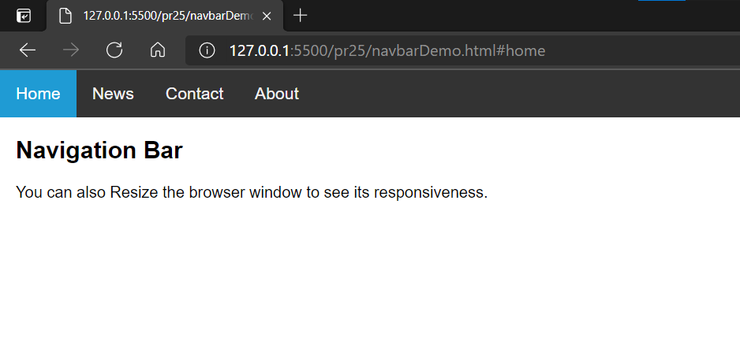

**Practical-26**

**Aim:** Create an Image slider using JQuery.

**Code:**

<!DOCTYPE html>

<html>

<head>

<title>JQuery Slider</title>

<script src="https://ajax.googleapis.com/ajax/libs/jquery/3.3.1/jquery.min.js"></script>

<link

href="https://maxcdn.bootstrapcdn.com/font-awesome/4.7.0/css/fontawesome.min.css"

rel="stylesheet"

integrity="sha384-wvfXpqpZZVQGK6TAh5PVlGOfQNHSoD2xbE+QkPxCAFlNEevoEH3Sl0sibVcOQVnN"

crossorigin="anonymous"

/>

<style>

body{

font-family: helvetica;

background:linear-gradient(90deg,#0af5a6,#079afc);

}

#slider {

width: 70%;

height: 500px;

margin: 20px auto;

position: relative;

}

div#slider {

overflow: hidden;

border: 5px solid white;

border-radius: 20px;

}

div#slider figure img {

width: 20%;

height: 100%;

float: left;

}

div#slider figure {

position: relative;

width: 500%;

height: 100%;

margin: 0;

left: 0;

transition: 1s ease-in-out;

}

.btn-next,

.btn-prev {

position: absolute;

top: 45%;

cursor: pointer;

color: white;

background-color: #ccc;

border: none;

}

.btn-prev {

left: 0px;

border-radius: 0 50% 50% 0;

}

.btn-next {

right: 0px;

border-radius: 50% 0 0 50%;

}

</style>

</head>

<body>

<center>

<h1 style="color: white">JQuery Slider</h1>

</center>

<div id="slider">

<figure>

<img src="1.jpg" width="100%" height="100%" />

<img src="2.jpg" width="100%" height="100%" />

<img src="3.jpg" width="100%" height="100%" />

<img src="4.jpg" width="100%" height="100%" />

<img src="5.jpg" width="100%" height="100%" />

</figure>

<button class="btn-prev">

<img

src="https://img.icons8.com/color/48/000000/double-left--v2.png"

style="width: 30px; margin-top: 5px"

/>

</button>

<button class="btn-next">

<img

src="https://img.icons8.com/color/48/000000/double-right--v2.png"

style="width: 30px; margin-top: 5px"

/>

</button>

</div>

<script type="text/javascript">

$(document).ready(function () {

var x = 0;

// for next slide

$(".btn-next").click(function () {

x = x <= 300 ? x + 100 : 0;

$("figure").css("left", -x + "%");

});

// for prev slide

$(".btn-prev").click(function () {

x = x >= 100 ? x - 100 : 400;

$("figure").css("left", -x + "%");

});

});

</script>

</body>

</html>

**Output:**

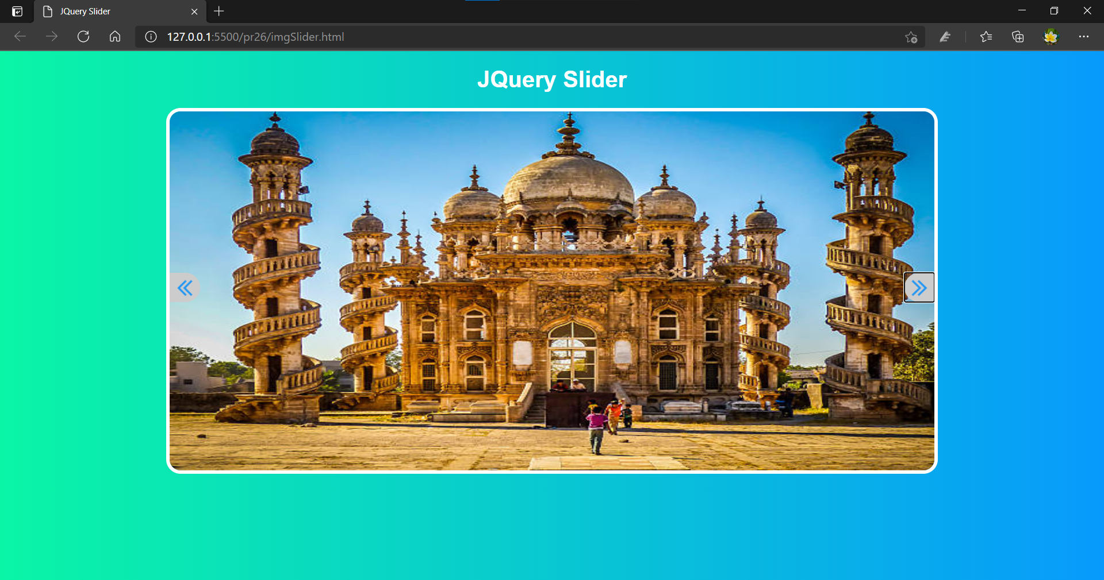

**Practical-27**

**Aim:** Demonstrate Rest API with PHP.

**Code:**

**api.php**

<?php

$connect =

mysqli_connect("localhost","abhi","abhi","dmeo2");

$response = array();

if($connect){

$sql = "SELECT * FROM student";

if($result = mysqli_query($connect,$sql)){

header("Content-type: JSON");

$i =0;

while($rows = mysqli_fetch_array($result)){

$response[$i]['id'] = $rows['id'];

$response[$i]['name'] = $rows['studname'];

$response[$i]['enrollment'] = $rows['enrollment'];

$response[$i]['Branch'] = $rows['studbranch'];180160116019

$response[$i]['Email'] = $rows['studemail'];

$i++;

}

echo json_encode($response, JSON_PRETTY_PRINT);

}

}

else {

echo "Connection Failed";

}

?>

**Output:**

